

IN THE HIGH COURT OF SWAZILAND

HELD AT MBABANE CASE NO. 366/17

In the matter between:

MFUNDO BHALA SHONGWE APPLICANT
and

REX RESPONDENT

Neutral Citation : Mfundo Bhala Shongwe vs The King (366/17) [2017]
SZHC 262 (5 DECEMBER 2017)

Coram : MABUZA – PJ
Heard : 8 NOVEMBER 2017
Delivered : 5 DECEMBER 2017

SUMMARY
Criminal Procedure – Appeal from the Magistrates Court – Appeal against sentence – That sentence is harsh and induces sense of shock – Sentence not harsh – Sentence reduced as circumstances of Accused not taken into account.
JUDGMENT
MABUZA -PJ
[1] The Appellant was charged with the offence of Contravening Section 3 (1) of the Girls and Women’s Protection Act 39/1929. He pleaded guilty and was accordingly convicted and sentenced to three (3) years imprisonment without the option of paying a fine by the Magistrate’s Court sitting at Mbabane.

[2] The Appellant has noted an appeal against the sentence imposed by the court a quo on the following basis:
- The court a quo misdirected itself in law by failing to deal with
the three competing aspects of the triad when arriving at a proper sentence to be meted out to the Appellant.

- The court a quo failed to advance any reasons why the Appellant could not be afforded an option of paying a fine and why a portion of his sentence could not be suspended.

- The court a quo erred both in fact and in law by treating the offence the Appellant was charged with as one of rape when it is clear from the evidence that the sexual intercourse between the Appellant and the complainant was consensual.

- The sentence imposed by the court a quo is harsh and induces a sense of shock.
[3] The background hereto was that the Appellant had sexual intercourse with a female minor who was 14 years old on the 24the June 2017.

[4] When she gave her testimony the complainant confirmed that she was 14 years old and that she and the Appellant were in a relationship. She testified that the relationship began in June 2017 when the Appellant proposed to her and she accepted his proposal. Shortly after that they had consensual sexual intercourse in his house. They had consensual sex on four separate occasions.

[5] The Accused pleaded guilty. He too confirmed that he had consensual sex with the complainant.

[6] The age of the complainant being 14 years old was confirmed by her biological mother. A birth certificate (Exhibit “A”) that she was 14 years old proved that fact.

[7] It was argued before me on behalf of the Appellant that the competing aspects of the triad are the nature of the crime, the interests of society and the interests of the Accused. See S V Zinn 1969 (2) S.A. 537.

[8] Taking her submission further Ms. Ndlangamandla for the Appellant in her heads of argument stated as follows:
“6. In coming to the sentencing, the Court only took into account the interests of society and no consideration whatsoever was made to the personal circumstances of the Applicant, whom it is common cause was a first offender who had children who still school going.

7. The Court failed to take into account the age of the Appellant and the circumstances surrounding the commission of the offence (including that the Appellant was not in his sober senses when the offence was committed and it is submitted that had it done so, it would not have sentenced him to eight (8) years imprisonment without the option of paying a fine.

[9] I think that she meant three years and not eight years. I agree with learned Counsel for the Appellant that the judgment on sentence by the learned Magistrate failed to take the personal circumstances of the Appellant into account. I think that this was an oversight on the part of the learned Magistrate. That being the case I shall interfere with the sentence in as far as ground of appeal (a) is concerned.

[10] As far as ground of appeal (b) is concerned, the Magistrate dealt adequately with same. I agree with the learned Magistrate that there is no provision for a fine except a custodial sentence with or without a fine (of one thousand Emalangeni) with or without whipping (not executing 24 strokes). This is what 3 (1) of the Girls and Women Protection Act 39/1920 states:

“Every male person who has unlawful carnal connection with a girl under the age of sixteen (16) years or who commits with a girl under the age immoral or indecent acts or who solicits or entices a girl under such age to the commission of such acts shall be guilty of an offence and liable on conviction to imprisonment not exceeding six (6) years with or without whipping not exceeding twenty-four (24) lashes and with or without a fine not exceeding One thousand Emalangeni (E1,000.00) in addition to such imprisonment and lashes”.

[11] With respect to ground of appeal (c), I deal with this ground in my reasons for interfering with the sentence.

[12] With respect to ground of appeal (d), the sentence is not harsh nor does it induce a sense of shock because if falls within the range set out by the statute as not exceeding six years imprisonment.

[13] Having stated that the failure to take the personal circumstances of the Appellant into account was an oversight, I feel obliged to reduce the sentence.

[14] The personal circumstances of the Appellant are that he has no previous conviction, he is a first offender, he has school going children, he is in tertiary college, that she consented to having sex with him. His age was not disclosed. I doubt that he was not in his sober senses during all four sexual incidents.

[15] The appeal against sentence succeeds and the sentence of the learned Magistrate is set aside and substituted with the following:
- The Accused is sentenced to two years imprisonment without an option
of a fine, one year is suspended for one year on condition that the Accused is not convicted of a crime mentioned in section 3 (1) of the Girls and Women’s Protection Act 39/1929.

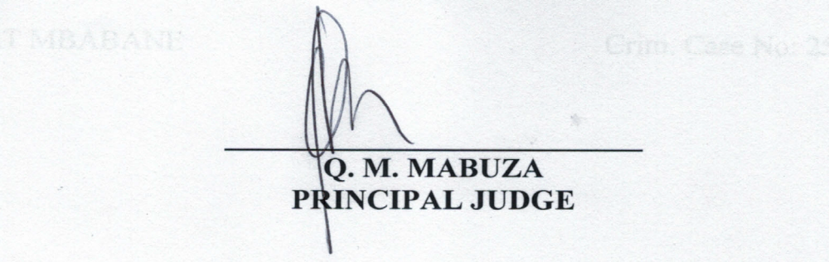
For the Applicant : Ms. Ndlangamandla
For the Respondent : Miss Matsebula

