

IN THE HIGH COURT OF SWAZILAND

HELD AT MBABANE CASE NO. 114/16

In the matter between:

REX

and

THABISO SURPRISE DLAMINI

Neutral Citation : Rex vs Thabiso Surprise Dlamini (114/16) [2018]
SZHC 174 (31 JULY 2018)

Coram : MABUZA – PJ
Heard : 24 JULY 2018
Delivered : 31 JULY 2018

SUMMARY

Criminal Law – Accused convicted of attempted murder – Sentence
– Personal circumstances of Accused – The crime –
Society’s expectation of sentences.

JUDGMENT ON SENTENCE

MABUZA -PJ
[1] The Accused stands charged with the offence of attempted murder in that upon or about 25th December 2015 and at or near Bhekinkosi area in the Manzini Region, the said accused person did unlawfully and with intent to kill stab one Wandile Dlamini three times (3) with a knife.

[2] When the charge was put to him, the Accused pleaded guilty to the offence.

[3] A statement of agreed facts which was signed by him and the Crown was filed off record.

[4] The statement of agreed facts was read over to him and he confirmed its
contents.

[5] The statement is marked Exhibit A. The medico legal report is marked Exhibit B. The knife Exhibit 1. I convicted the Accused and found him guilty as charged and per his plea of guilty to the charge.

[6] The Crown advised the Court that the Accused is a first offender, he has no previous convictions.

[7] In mitigation the Accused stated that he was born on the 1/5/1995 and that he was 23 years old. That he was arrested on 25th December 2015 and has been in custody since (2 years – 7 months)

[8] He completed Form 5 during 2015 and had credited all eight subjects that he had registered for. He had applied to various tertiary institutions in order to further his studies namely SCOT, UNISWA (Kwaluseni) and (Luyengo). He was interested in pursuing Civil Engineering Degree, Agronomy or Construction. But these hopes were dashed by this incident which got him arrested.

[9] His mother was deceased and his father is still alive. He had a girlfriend prior to his arrest, who fell pregnant and gave birth to a baby girl while he was in custody. His girlfriend does not visit him and he has never seen his child.

[10] He stated that he was very sorry and remorseful about what happened and that he had never hurt anybody in his life. He blamed his actions on the fact that he and his friends had started drinking whisky on the previous day and had not slept. It was Christmas season.

[11] He says that he was so drunk that he could not reason properly and that the knife that he used on the complainant did not belong to him. He took it from someone else at the bar. He did not even know the complainant.

[12] The complainant was present in Court and the Accused requested permission to apologise to him. The Court allowed him to do so and the complainant forgave him.

[13] I shall take all the above personal submissions on mitigation into account in passing sentence. I was struck by the Accused’s remorse. He sounded very genuine and this too shall go to his credit.

[14] I shall factor into the sentence the fact that the crime is a serious one and the Accused is lucky that the complainant was not fatally stabbed in spite of the three stab wounds that the Accused inflicted on him. The knife looked wicked and the blade measured about 8 cms.

[15] Stabbings are a primary cause of bodily harm and murders. The courts take a serious view of such violence and so does society.

[16] Society expects the courts to be vigilant and proactive when crimes of this nature occur. And that sentences should deter would be offenders.

[17] The medical report confirmed the stab wounds inflicted upon the complainant by the Accused.

[18] In view of the foregoing, the Accused is sentenced to 7 years imprisonment without an option of a fine, two years of which are suspended for one year on condition that the Accused is not convicted of any crime of which assault is an element.

[19] The sentence is backdated to the 25th December 2015, the date on which he was lawfully arrested for this crime.

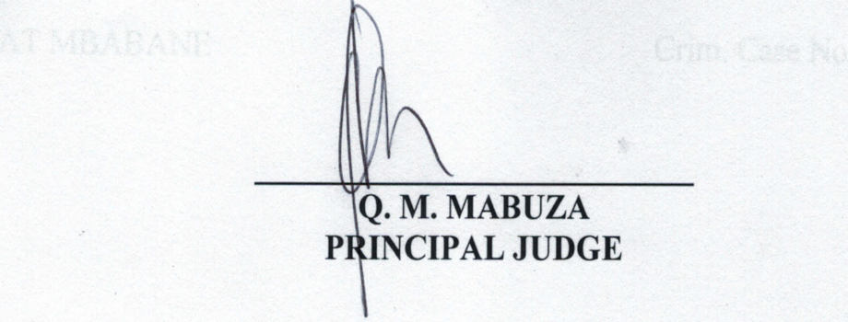

For the Crown : Ms. Mabila
For the Accused : In person

