

IN THE HIGH COURT OF ESWATINI

HELD AT MBABANE CASE NO. 1564/2014

In the matter between:

NKOSINGIPHILE SHONGWE APPLICANT
and

UMBUTFO SWAZILAND DEFENCE FORCE 1ST RESPONDENT
THE ATTORNEY GENERAL 2ND RESPONDENT

Neutral Citation : Nkosingiphile Songwe vs Umbutfo Swaziland Defence
Force and Another (1564/2014) [2019] SZHC 10 (19 FEBRUARY 19

Coram : MABUZA – PJ
Heard : 06 JULY 2018
Delivered : 30 APRIL 2019

SUMMARY
The Applicant’s claim is against the 1st Respondent for payment of her
Arrear salary for the months of January 2012 to March 2015. Because
of its labour relations nature; no order made on the matter. Costs
awarded to the Applicant.

JUDGMENT
MABUZA -PJ
[1] Serving before me is an application brought by the Applicant for an order in the following terms:
- Ordering and directing the 1st Respondent to pay the Applicant her arrear
salary for the months of January 2012 to March 2015 in the total sum of E329,271.09 (three hundred and twenty nine thousand two hundred and seventy one Emalangeni nine cents) within 21 days of grant of this order.

- Costs of suit at attorney and own client scale in the event the application
is opposed.

- Further and/or alternative relief.

[2] The application is opposed by the Umbutfo Eswatini Defence Force, the 1st Respondent (hereinafter referred to as the Defence Force) herein represented by the Attorney General (the 2nd Respondent).

[3] The Applicant says that on or about 2005 she was recruited by the 1st Respondent and became a private soldier within six months of training and was thereafter stationed at Phocweni Army Barracks on Royal Guard. She says that during 2008 she fell ill and was admitted for treatment at the National Psychiatric Hospital under the care of Dr. R. Charum. She was treated and discharged to resume work.

[4] She says that from 2008 onwards she would be in and out of hospital and during this time was paid her full salary. When she fell ill again during 2012, her supervisor Major M.S. Ndlangamandla was of the opinion that she should retire on medical grounds. She was sent to the National Psychiatric Hospital to be re-evaluated for that purpose.

[5] However, Dr. Charum wrote a letter to her superiors stating that she was on treatment and should be allowed to come for review on a monthly basis. The doctor did not recommend that she be boarded on medical grounds.

[6] The 1st Respondent in an affidavit sworn to by General Sobantu S. Dlamini the Army Commander of the Defence Force, does not deny the above background story as set out by the Applicant. He even goes on to state that after her psychiatric evaluation the doctor recommended that since the Applicant was still young, retirement would exacerbate her mental illness and recommended that she be retained but given light duties. She was given light duties at the clinic’s staff kitchen at Phocweni Clinic.

[7] The Applicant says that sometime in January 2012 she was informed by Major Gugu Zwane and Major Thobile Ndwandwe that she had been dismissed from work and that her salary had been stopped. Indeed her salary was stopped from February 2012.

[8] The Army Commander in his answering affidavit (para 11) denies that the Applicant was dismissed and admits that only her salary was stopped for absenteeism because there was no proof of the Applicant being sick.

[9] Colonel Mandla James Ndlangamandla in a confirmatory affidavit to that of the Army Commander states that he was the one who recommended that the Applicant be retired on medical grounds due to her mental illness.

[10] He confirms that in spite of this recommendation the national Psychiatric Hospital refused that she be retired on medical grounds on the basis that she was still young and such would exacerbate her mental illness. They recommended that she be redeployed to do light duty instead. He redeployed her as stated above on the Army Commander’s request. He says that todate she is based at the Phocweni Clinic kitchen where she cleans and makes tea for the staff.

[11] Lieutenant Gugu Zwane in her confirmatory affidavit states that the Applicant’s salary was stopped because of her long absences without reporting. Lieutenant Thobile Ndwandwe also confirms that the Applicant absented herself for several months without reporting her whereabouts and the reasons for her absence. She like Lieutenant Zwane says that sometimes they would proceed to the Applicant’s home to look for her but upon seeing them, the Applicant would run away.

[12] At paragraph 8 of his affidavit the Army Commander says

“May I state that at all these occasions, there was no medical report either from the Psychiatric hospital to the effect that the Applicant was not fit to work, meaning she would stay at home on her own volition”

Elsewhere at paragraph 12 he says:

“May I state that the Applicant’s sickness began in 2008 and all the time while she was sick she would get her salary. It was only when she would stay away from work without any report that she was sick would her salary be stopped”.

[13] It is clear from the evidence that I have outlined above that the Applicant was ill. Her superiors knew that she was ill. Colonel Ndlangamandla even recommended that she be retired on medical grounds. Her erratic behavior in absenting herself from work, running away upon seeing her superiors or even her mother and brothers bringing her to work whereupon she would disappear after a day or two. Something was definitely wrong with her which warranted putting into effect retirement proceedings on medical grounds and or proceedings for her medical boarding but not to stop her salary unilaterally without due process.

[14] The Applicant further states that around November 2014 she filed review proceedings against the 1st Respondent for unlawfully terminating her services and the failure by the 1st Respondent to giving her an opportunity to be heard before terminating her services.

[15] She says that the 2nd Respondent only filed a notice to oppose and an order that she be re-instated to work was issued on the 27th February 2015 before then Acting Judge Brian Magagula (the former Judge is also the Commissioner of Oaths for all the affidavits of the 1st Respondent). The Army Commander in his answering affidavit says that the reason the application was not opposed was mainly because the Applicant had not been dismissed but only her salary was stopped for absenteeism without any reason or proof of her being sick whatsoever.

[16] The Applicant has attached the Court Order to her founding affidavit as Annexure “NS3”. I reproduce its contents hereunder:

“COURT ORDER
Having heard Counsel for the Applicants and the Respondents

IT IS HEREBY ORDERED THAT:
- The Applicant is re-instated to her position of being a member of the Umbutfo Swaziland Defence Force

GIVEN UNDER MY HAND AND SEAL AT MBABANE ON THIS 4TH DAY OF FEBRUARY 2015

BY ORDER OF COURT
REGISTRAR – HIGH COURT”

[17] I have reproduced the order because Mr. Hlawe in his heads of argument at paragraph 14 states as follows:
“On the 27 February 2015 this Court issued an order which reads thus:
‘It is ordered that Applicant be reinstated to the position of being member
of Umbutfo Swaziland Defence Force, effect as of 2nd March 2015’ ”

[18] Mr. Hlawe has not attached any copy of the order referred to in his heads of argument which differs materially with Annexure NS3 filed by the Applicant and signed by Mr. Bhembe the erstwhile Registrar of this Court.

[19] The Army Commander admitted to Annexure “NS3” at paragraph 11 of his answering affidavit. He did not dispute the non-addition of “effective as of 2nd March 2015”. In the event I accept the contents of Annexure NS3 as does Mr. Hlawe’s clients.

[20] The Applicant says that when she resumed work in April 2015, to her shock and disbelief, her pay slip reflected that she was entitled to net pay of E0.00. That the salary advice slip reflected that her salary had been overpaid in the sum of E14,254.11 (Fourteen thousand two hundred and fifty four Emalangeni eleven cents). She says that she does not have any knowledge of the alleged overpayment. She approached the accounts office of the 1st Respondent to enquire about the deduction and she was informed that it was the amount that they had paid her when she was not working whilst still sick which sums they said she had not been entitled to.

[21] The Army Commander’s response at paragraph 12 of the answering affidavit is to deny that the Applicant’s salary was stopped while she was sick, the rest of the contents of her paragraphs 6 to 9 are admitted. He obviously admits to her salary being deducted but does not specifically address why it was deducted and why her salary slip reflected E0.00.

[22] She has claimed arrears in salary in the sum of E329,271.09 (Three hundred and twenty nine thousand two hundred and seventy one Emalangeni nine cents). The Army Commander’s response is that there are no arrears due to her as the money deducted was because of her absenteeism.

[23] It is important to note that the deductions for absenteeism span over the 28 months that she says she was not paid. The Respondents cannot therefore be heard to say her claim has prescribed when they themselves were able to help themselves to money paid for this period.

[24] I understand the Army Commander to be saying that the Applicant was never dismissed and perhaps like me is perplexed by the order of reinstatement to her position of being a member of the Defence Force. According to him she has never not been a member of the Defence Force. The legal arguments (impressive as they are) with regard to the meaning of re-instatement are in my view not applicable. I note further that the affidavit of the Army Commander was deposed to on the 13th April 2017, while the order (NS3) was issued on the 4th February 2015. The Army Commander affidavit clarifies the order even further. I note further that the Commissioner of Oaths to his affidavit being the Acting Judge who issued the order and being the Principal Crown Counsel by implication is approving of the clarification of the Court Order (NS3) by the Army Commander.

[25] Having noted this, the final question would be whether this Court is competent to grant prayer (a) of the Applicants notice of motion.

[26] The Army Commander has clarified that the Applicant’s services were not terminated only her salary was stopped because of absenteeism. She was never charged for absenteeism. On the other hand the Applicant has not taken the Court into her confidence by informing the Court where she was from January 2012, (after she ostensibly learnt about her termination, which has been denied) and November 2014 when she approached the Court on review.

[27] Where was she? What was she doing during this period? If she was ill during this period she has not filed any medical proof to that effect. How then can this Court order that she be paid for this period? She resurfaced in January 2013 and after a day or two disappeared again until April 2015 when she resumed work.

[28] Because the Applicant’s services were not terminated the appropriate forum for claiming payment of her arrear salary is the fora for labour matters. There the 1st Respondent will provide proof of the days when she was absent. Likewise she will provide medical proof that she was ill during the days when she was absent. In the circumstances:
- I make no order on the substantive claim.

(b) Each party is ordered to pay its own costs.

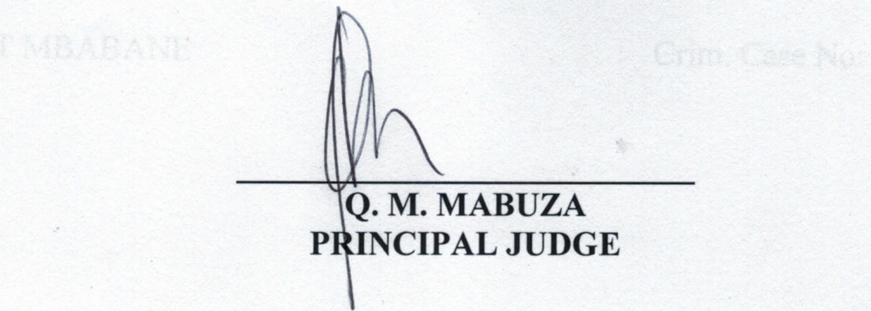
For the Applicant : Mr. Motsa
For the Respondent : Mr. Hlawe (AG)

