

IN THE HIGH COURT OF SWAZILAND

HELD AT MBABANE CASE NO. 211/2013

In the matter between:

REX

and

THEMBA THEMBINKOSI DLAMINI

Neutral Citation : Rex versus Themba Thembinkosi Dlamini (211/2013)
[2019] SZHC 22 (19 FEBRUARY 2019)

Coram : MABUZA – PJ
Heard : 11 FEBRUARY 2019
Delivered : 19 FEBRUARY 2019

SUMMARY
Criminal Law: Accused charged with murder – Pleads guilty
to culpable homicide - Crown accepts plea – Accused convicted for culpable homicide.
Sentence: Accused sentenced to 7 years imprisonment without
option of fine – Sentence backdated to date of arrest.

JUDGMENT ON SENTENCE
MABUZA -PJ
[1] The Accused was charged with the murder of his wife Xolile Mdluli. He pleaded guilty to the crime of culpable homicide stating that her death was accidental. Mr. Bhembe, his lawyer, confirmed the plea of guilty as being consistent with his instructions. Miss Mabila for the Crown accepted the lessor plea of culpable homicide. The Accused recorded a statement of agreed facts (Exhibit A) which sets out how the deceased died. The statement of agreed facts was read unto the record.

[2] The Accused and the deceased hail from Tibane in the Shiselweni Region under Chief Gasa Wakangwane. The deceased died on the 6th April 2013 as a result of an assault inflicted on her by the Accused. He stated that he assaulted her with a log several times on her head, on the right side of her chin near the lower lip, over the left forearm and over the left thigh.

[3] Her injuries are confirmed by the Government Pathologist Dr. R.M. Reddy in a post mortem report dated 10th April 2013 (Exhibit B) in which is stated that the cause of death was due to multiple injuries.

[4] The couple set out drinking homemade brew on the 6th April 2013. After sometime they left the drinking spot and made their way home. Along the way the Accused had an argument with the deceased because she had left their place of abode during the Easter weekend and did not return on time. She told him that she had found a new boyfriend and had been with this boyfriend during the Easter weekend.

[5] The Accused became angry, took a log and struck her with it mainly on her head. He left for home without her. He says that she was alive when he left her and she was sitting down, resting.

[6] He heard on the following day that she was found dead on the spot where he had left her. He was arrested on the 7th April 2013 and charged with her murder. He has been in custody since then.

[7] The log was handed in as Exhibit 1. The sworn statement and key Photographs made and taken by 5380 D/C Thulane Gama was handed in as Exhibit C.

[8] The statement of agreed facts was interpreted to the Accused from English to Siswati and asked if he agreed with its contents. He agreed.

[9] Thereafter the Accused was found guilty of the death of the deceased and convicted with the crime of culpable homicide.

[10] Miss Mabila advised the Court that the Accused was a first offender and had no previous convictions.

[11] Mr. Bhembe made submissions on mitigating circumstances on behalf of the Accused. It was submitted that the Accused was 40 years old. His level of education was Form III. That the Accused was remorseful that is why he had pleaded guilty to the accidental death of his wife and by pleading guilty he had not wasted the court’s time. And that throughout his 40 years he had led a crime free life. That he had a 14 year old daughter that he used to support. That the death of his wife will haunt him all the days of his life.

[12] That the Court should take into account the triad and tamper its sentence with mercy. And to bear in mind that the range of sentences in a matter such as this one was 7 to 10 years imprisonment.

[13] In response Miss Mabila conceded that even though this was a crime of passion, the Court should take into account the interests of society.

[14] In passing sentence I have taken Mr. Bhembe’s submissions on mitigation in regard to the Accused’s personal circumstances especially that the Accused was remorseful and that he has less a crime free life. And that this was a first offence which will haunt him all his life.

[15] I have also taken into account the nature of the crime. He hit her multiple times with a log particularly around her head. He left her out in the open field where she died. The photographs of her show her bloody face.

[16] Domestic violence leading to the death of a spouse is prevalent in our society and must be stopped. Courts must pass sentences that sent a message to would be offenders to desist from such crimes.

[17] I have also taken into account the interests of society. Society expects the courts to pass deterrent sentences. Society wants protection and the comfort that the courts look out for them.

[18] The range of sentences in cases such as this one is as Mr. Bhembe indicated; between 7 years to 10 years imprisonment. However, this depends on the severity of the assault and the weapon used to inflict the fatal injuries.

[19] The deceased and the Accused had been drinking all afternoon. Tempers flare up over anything and in this case it was the issue of a new boyfriend that the deceased admitted she had been with. That being the case the Accused had no right to assault her nor to kill her whatever the circumstances.

[20] In the event, the Accused is sentenced to seven (7) years imprisonment without an option of a fine. The sentence is backdated to the 7th April 2013, the date on which he was arrested and taken into lawful custody for the commission of this offence.

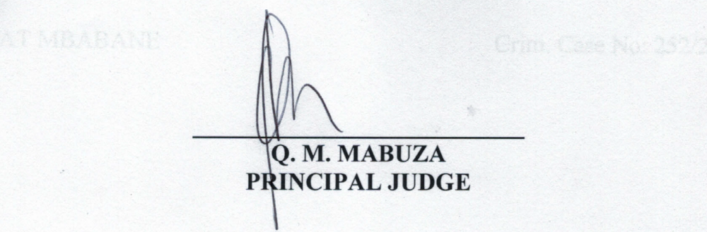

For the Crown : Ms. N. Mabila
For the Accused : Mr. S. Bhembe

