

IN THE HIGH COURT OF ESWATINI

HELD AT MBABANE CASE NO. 1473/2014

In the matter between:

LAWRENCE MATSE APPLICANT
And
LOMAKHOSI DLAMINI

In re:

LOMAKHOSI DLAMINI
and
LAWRENCE MATSE RESPONDENT

Neutral Citation : Lawrence Matse and Lomakhosi Dlamini (1473/2014)
[2019] SZHC 08 (19 FEBRUARY 20179)

Coram : MABUZA – PJ
Heard : 06 JULY 2018
Delivered : 19 FEBRUARY 2019

SUMMARY
Civil Procedure – Application for rescission of default judgment – Judgment
granted at a stage when pleadings joined and matter ready
for trial – Application granted.

JUDGMENT
MABUZA -PJ
[1] Before me is an application for rescission of a judgment granted by default against the Applicant (Mr. Matse) on the 18th April 2017. The order was that Mr. Matse pay the Respondent the sum of E103,386.20 (One hundred and three thousand, three hundred and eighty six Emalangeni, twenty cents) together with interest at the rate of 9% per annum from date of issue of summons to date of final payment and costs of suit.

[2] The application for rescission is opposed by the Respondent.

[3] The application for rescission is brought under Rule 42 (1) (a) which provides as follows:
“42 (1) The court may, in addition to any other powers it may have, mero motu or upon the application of any party affected, rescind or vary:
- an order or judgment erroneously granted in the absence of any party affected thereby.”

[4] In order to succeed in his application the Applicant should comply with the following requirements:
- That his default was not wilful; and
- That he has a bona fide defence which prima facie carries some
prospects of success.

Whether or not in wilful default
[5] The Applicant says that the judgment sought to be rescinded was granted in his absence and that of his erstwhile attorneys. The Respondent in her answering affidavit admits that the said judgment was granted in the Applicant’s absence and in the absence of his attorneys. She also states that her attorneys caused a notice of set down to be served on the Applicant’s Correspondent attorneys.

[6] Indeed that notice of set down was signed by the Respondent’s attorneys on the 14th February 2017 and served on the correspondent attorneys, Messrs S.V, Mdladla and Associates on the 15th February 2017. The set down notified the Applicant’s attorneys that the dates of trial would be the 17th and 18th April 2017.

[7] The Applicant says that he was in default of attendance because he was not notified by his erstwhile attorneys of that date.

[8] The Respondent’s response is that the matter was duly published and a roll call was conducted by the leaned Judge where the matter was allocated two trial dates for the 18th and 19th April 2017. The Respondent concedes that the Applicant and erstwhile attorneys were not present on the stated dates, despite the wide and elaborate notices that the learned Judge would be conducting a roll call.

[9] The date of the roll call is not stated. The notice (s) that the Respondent says were circulated widely by the Judge are not attached. I am unable to make a finding in this regard.

[10] The Respondent further states that the Applicants erstwhile attorneys were duly and timeously served with a notice of set down for the dates of trial. Annexure LJ is attached as proof of a copy of the notice of set down for trial duly served and acknowledged by the Applicant’s erstwhile attorneys’ correspondents.

[11] The Applicant says that he was not in wilful default and that his absence was because his erstwhile attorneys did not notify him of the dates of trial. If this is true it is very tragic and should be taken up with the Law Society of Eswatini. Unfortunately the Applicant did not file an affidavit from his erstwhile attorneys as to whether or not they received the notice of set down from S.V. Mdladla and Associates.

[12] Nevertheless I shall give him the benefit of the doubt and accept his explanation that his default was not wilful particularly as he had filed a notice of intention to defend the main matter and even went on further to file a plea, a pre-trial was conducted, minutes of the pre-trial conference were signed and filed. This to me indicates that he had at all material times intended to defend the matter. A further point in his favour is that the amount of E103,386.20 claimed by the Respondent is no small amount to be taken lightly to the point of having a default judgment granted against him. At best the matter ought to have been postponed or even struck off with costs awarded to the Respondent as the matter was ready for trial on its merits and not at summary judgment stage.

[13] I note the point the Respondent makes that an attorney acts on the instructions of his client but I disagree that the actions or inactions of the attorney are at law imputed on the litigant. In the case of Phinda Sibonginkosi Matse & Another vs Jabulile Beauty Dlamini & Two Others case no. 1793/2015 (unreported) at page 10 – 11 I noted as follows:
“(e) What we have is an error of the legal advisor. Should this Court allow that error to be visited on the Applicants. In my view the error of the legal advisor should not necessarily be visited on her clients. In saying so I find support in the case of Phillip Chemwolo & Another v Augustine Kubende [1982 – 88] KAR 103 where the Court of Appeal of Kenya held:

“Blunders will continue to be made from time to time and it does not follow that because the mistake has been made that a party should suffer the penalty of not having his case heard on merit … the broad equity approach to this matter is that unless there is fraud or intention to overreach, there is no error or default that cannot be put right by payment of costs. The courts as is often said, exist for the purpose of deciding the rights of the parties and not for the purpose of imposing discipline.”

[14] I am also mindful of the audi alterem rule to hear also the other side. And the constitutional provision that a person has a right to a fair hearing. It should be a hollow victory to win on a technicality and not on the merits.

A bona fide defence
[15] The Applicant’s defence is set out at paragraph 14 to 14.6 of his founding affidavit as follows:

“14. I wish to further state that I have good cause and bona fide defence to the action. The defence is set out herein below:

14.1 There is a matter concerning the same parties and the same subject matter pending before the Honourable Court under case no. 836/2013 hence the present matter is lis pendens.

14.2 I agreed to sell the business (Angels Rest and Bar) situate at Shop No.7 Plot No. 110 Martin Street Manzini at E130,000.00 instead of E260,000.00 to the Respondent because of the arrear rentals owed to SPM

14.3 Initially, the Respondent negotiated for the reduce price on condition that she would operate the business for three years. However, the parties ended up not signing the sublease for the said period as the Respondent wanted five (5) years.

14.4 The parties reached a deadlock, which culminated in the application under case no. 836/2013 wherein the Respondent sought an order inter alia compelling me to accompany her to the landlord to effect change of the lease agreement between me and the landlord SPM to reflect the Respondent as the lessee.

14.5 The parties agreed in principle to settle the matter out of court by making proposals that Respondent would settle the arrear rentals with SPM and thereafter takeover my lease with SPM as form of compromise. Subsequently, the Respondent out of her own volition paid the said arrear rentals and got the lease as agreed. However, the parties ended up not reducing what they have agreed on into writing to be made an order of court and as such the matter under case no. 836/2013 is still pending in court.

14.6 On account of the foregoing, it is clear that I am not indebted to the Respondent in the amount claimed in the summons and/or any amount whatsoever hence the submission that I have a good and bona fide defence to the action.

[16] I may further mention that a similar defence is raised in the main plea. It is obvious that the Respondent envisaged that a dispute of facts would arise hence the issuance of a summons. She accepted the plea without filing for summary judgment. Critically she even filed a replication to the plea. I would surmise that she too wanted a full ventilation of the matters being disputed.

[17] In my view a bona fide defence has been established by the Applicant. I note the Respondent’s complaint with regard to the delay in bringing this application. I cannot punish the Applicant because of the incompetence of his erstwhile attorneys. For example the noting of the appeal was another incompetent step when the proper cause of action was the rescission application. That appeal delayed the matter even further.

Costs
[18] It is unfortunate that the Applicant failed to join his erstwhile attorneys in these proceedings because I would not have hesitated in issuing a costs order against them. Because of this failure, I order that the Applicant pay the costs of this application.

[19] I order as follows:
- The application for rescission is hereby granted and the order
granted by default on the 18th April 2017 is hereby rescinded
and set aside.

- The Applicant is granted leave to defend the action.

- The Applicant is ordered to pay the costs of this application.

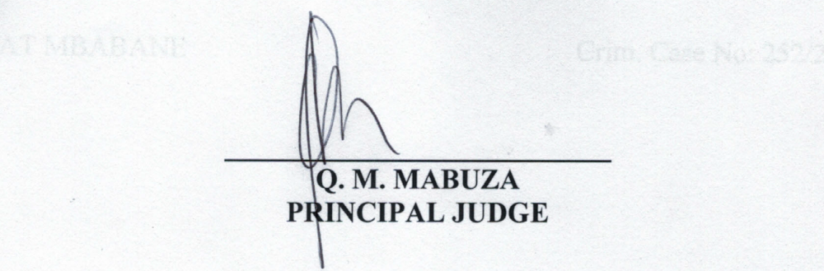

For the Applicant : T.N. Sibandze
For the Respondent : M. Tsambokhulu

