

IN THE HIGH COURT OF SWAZILAND

HELD AT MBABANE CASE NO. 111/2010
In the matter between:

THE KING
versus

ZAMOKUHLE MAKWASI MKHONTO

Neutral Citation : The King v Zamokuhle Makwasi Mkhonto
(111/2010) [2020] SZHC 153 (13 August 2020)

Coram : MABUZA – PJ

Heard : 21/07/20
Delivered : 14/08/20

SUMMARY

Criminal law - Accused pleaded guilty to three counts: one count of Culpable Homicide and two
counts of Assault with Intent to do Grievous Bodily Harm – Crown accepts pleas – pleas confirmed by Accused’s attorney – convicted and sentenced accordingly.

JUDGMENT

[1] The Accused Zamokuhle Makwasi Mkhonto was arraigned before me and charged as follows:
Count 1
The Accused was charged with the crime of Murder in that upon or about the 1st January 2010 at or near Mangwaneni area in the Hhohho Region, the Accused unlawfully and intentionally kill Menzi Shiba and did thereby commit the crime of Murder.

[2] When the charge was put to him he pleaded not guilty to Murder and guilty to Culpable Homicide.
Count 2
The Accused was charged with the crime of the Attempted Murder in that upon or about the 1st January 2010 at or near Mangwaneni area in the Hhohho Region, the Accused did unlawfully stab Ntokozo Shabangu with a knife on the left breast with the intention to kill him and did thereby commit the crime of Attempted Murder.

[3] When the charge was put to him the Accused pleaded not guilty to the crime of Attempted Murder and guilty to the crime of Assault with Intent to Cause Grievous Bodily Harm.
Count 3
The Accused was charged with the crime of Assault with Intent to Cause Grievous Bodily Harm in that upon or about the 1st January 2010 at or near Mangwaneni area in the Hhohho Region, the Accused did unlawfully stab Mzamo Dlamini on the right hand with the intention of causing him grievous bodily harm.

[4] When the charge was put to him, the Accused pleaded guilty as charged.

[5] His Counsel, Mr. Simelane, confirmed the pleas as being consistent with his instructions.

[6] The Crown accepted all the pleas.

[7] A statement of agreed facts was read into the record and is reproduced hereunder:
1.
‘The accused stands charged with three (3) counts. It being alleged by the Crown that on the 1st January 2010 and at our near Mangwaneni area in the Hhohho Region, the said accused person did unlawfully and intentionally kill one MENZI SHIBA and did thereby commit the crime of MURDER. The accused is further charged with Attempted Murder of NTOKOZO SHABANGU in that on the same date (being the 1st January 2010) the accused did unlawfully and intentionally stab NTOKOZO SHABANGU on the upper body. On the last count the accused did unlawfully and intentionally stab MZAMO DLAMINI and thus charged with assault with intent to cause grievous bodily harm.
2.
In respect of the first count, the accused pleads guilty to a lesser charge of Culpable Homicide. The accused further pleads guilty to a lesser charge of assault with intent to cause grievous bodily harm in respect of count two and also pleads guilty to count three, as charged.
3.
The Accused further agrees to the following to have taken place during the commission of the offences:
3.1 On the early morning hours of the 1st January 2010 at around 0700hours the deceased was seated outside Sambulo Lubisi’s homestead with Sambulo enjoying alcoholic beverages. As the two imbibed on the alcohol, the accused who was in a questionable state of sobriety arrived and addressed the deceased that he (accused) was now around as the deceased wanted to see him. The deceased dismissed these utterances and informed accused that he had no reason to see him (accused). As the two continued to exchange words, the deceased pushed the accused away as he (deceased) indicated that he had no desire to see accused. A push and shove ensued between the two (accused and deceased) and at that point the accused stabbed the deceased on the right upper body before he fled the scene.
3.2 SAMBULO LUSISI raised an alarm and the complainant on count two, one NTOKOZO SHABANGU attempted to capture the accused who had taken flight. The accused then stabbed NTOKOZO SHABANGU when he tried to help capture him (accused). The accused stabbed NTOKOZO SHABANGU once on his upper body. SAMBULO LUBISI, NTOKOZO SHABANGU and others continued to chase after the accused without success.
3.3 The complainant on count three MZAMO DLAMINI was also attacked by accused while walking with friends from a drinking session. The accused had alighted from a pick-up motor vehicle. Upon alighting from the motor vehicle, the accused saw MZAMO and friends and a verbal brawl ensued and the accused then stabbed MZAMO DLAMINI on his hand as MZAMO DLAMINI tried to block the knife. The accused then took to his heels. This stabbing incident occurred before, accused stabbed the deceased and NTOKOZO SHABANGU. The accused was later arrested on the same day whilst sleeping at his homestead.
4.
Now the accused concedes and agrees to the following:
4.1 That he is responsible for all the offences complained off;
4.2 That his conduct was unlawful and without any legal justification (in respect of all the offences charged);
4.3 That he acted negligently in bringing about the death of the deceased;
4.4 That between his conduct and the death of the deceased, there was no novas actus intervener.
5.
The accused further agrees that the following be handed as part of evidence:
5.1 The murder weapon;
5.2 The post mortem report;
5.3 Medical certificate in respect of complainant in count two, one NTOKOZO SHABANGU;
5.4 Medical certificate in respect of complainant in count three, one MZAMO DLAMINI.’

[8] The exhibits were entered as follows:
- Exhibit A - Statement of agreed facts.
- Exhibit B - Post-mortem report.
- Exhibit C - Medical report in respect of Ntokozo Shabangu.
- Exhibit D - Medical report in respect of Mzamo Dlamini.
- Exhibit 1 - Knife.

[9] Counsel for the accused confirmed the exhibits and had no objection to them being handed into Court as part of the record.

[10] I found the accused guilty in respect of all three counts per his plea of guilty.

[11] Mr. Mngomezulu for the Crown submitted that the Accused had no previous records and that he was a first offender.

[12] Mr. Simelane made submissions on mitigation on behalf of the Accused.

RE: PERSONAL CIRCUMSTANCES
[13] He asked the Court to mete out a lenient sentence on account of the Accused being a first offender and that he was relatively young at 22 years old when he committed the offences during January 2010. The Accused was now 32 years old and had waited 10 years for the case to be heard.

[14] I was told that the Accused was arrested on the 1st January 2010 and released on bail on the 30th September 2010. That ever since his release on bail he has faithfully complied with the bail conditions in particular that of reporting to the Police Station and has attended Court wherever he was notified to do so. This Mr. Simelane says is a sign of remorse and shows a willingness to take his punishment.

[15] The Accused further accepted his part in the commission of the Crimes(s) in that there was an altercation with the complainants at night which led to the assault in the morning. Even though he was provoked this did not justify the killing of the deceased which he regretted. His use of alcohol also played a major role in the commission of the offence.

[16] He has learnt his lesson and that is why he pleaded guilty and did not waste the Court’s time in having the Crown mount a full trial.
[17] He says that all the complainants are from the same community and the stigma of killing a fellow villager has weighed on him heavily.

[18] H is not married but has a girlfriend with whom he lives and together they have three children; 8 years old, 4 years and 2 years old. His girlfriend and their children are dependent on him. He used to be employed by Peak Timbers but was laid off due to the current pandemic.

[19] Mr. Simelane has made out a good case on behalf of the Accused and all the above, submissions are cogent and I have taken them into account in passing sentence.
RE: THE CRIMES
[20] That said, I am constrained to take into account the nature of the crimes as well. In respect of Count 1 involving the death of Menzi Shiba. It is clear that the Accused was the initiator of the altercation being in the questionable state of sobriety alleged. Granted this was during the New Year festive season and had the Accused remained at home the life of the deceased would have been spared.
[21] According to the medical report the cause of death is stated as “Haemorrhage as a result of penetrating injury to right lung”. The deceased was only 19 years old compared to the Accused who was already 22 years old (see Exhibit B).

[22] The deceased’s death was totally unnecessary and when the people around him tried to stop the Accused he committed the crime in Count 2. He again used the knife to stab the complainant in Count 2. The doctor described the wound inflicted on Ntokozo Shabangu as being “a deep stab wound on the left breast.” The doctor described it as a severe chest injury. Accused was very lucky that the complainant was not killed. (See Exhibit C).

[23] Earlier on in a separate incident before committing the crimes in Count 1 and 2, the Accused stabbed Mzamo Dlamini, the complainant in Count 3. The doctor described the wound as moderate and that the tendon of the right middle finger was incised. (See Exhibit D).

RE: THE INTERESTS OFS SOCIETY
[24] I have to also take the interests of society aboard. A major societal concern is that of carrying a knife to social events while not sober. The Accused has not told the Court why he was carrying a knife at all. Deaths by the use of knives is common occurrence in our society. Even the Courts seem to be waging a losing battle in this area but we have to soldier on and continue passing sentences that not only fit the crime but must be deterrent to would be offenders. Society expects this from the Courts.

[25] Accordingly I sentence the Accused as follows:
COUNT 1
The Accused is sentenced to 7 (seven) years imprisonment without an option of a fine; two years are suspended for three years are suspended for three years on condition that he is not convicted of any crime of which assault is an element during the period of suspension.
COUNT 2
The Accused is sentenced to 5 (five) years imprisonment without an option of a fine.
COUNT 3
The Accused is sentenced to 2 (two) years imprisonment without an option of a fine.

[26] The sentences are ordered to run concurrently from date of conviction (21/7/10); eight (8) months are to be deducted from the sentence being the months he was in custody from arrest to release on bail.
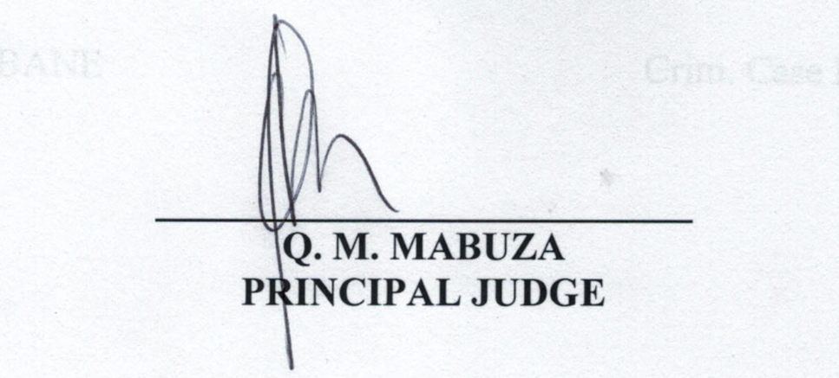
For the Crown : MR K. MNGOMEZULU
For the Accused : MR. S.C. SIMELANE

