IN THE HIGH COURT OF ESWATINI

HELD AT MBABANE CIVIL CASE NO. 1813/2019
In the matter between:

RICHARD DUMISANI NGWENYA APPLICANT

And

BAMBANANI BALIMI FARMERS LIMITED RESPONDENT

Neutral Citation: Richard Dumisani Ngwenya and Bambanani Balimi Farmers Limited (1813/2019) [2020] SZHC 215 (26 October 2020)

CORAM: Q.M. MABUZA PJ

DATE HEARD: 26TH MAY 2020
DATE DELIVERED: 26TH OCTOBER 2020

SUMMARY

Company Law: Applicant seeks payment of dividends on shares he owns with the Respondent – Respondent pleads non-liability due to pending possible termination of membership of Applicant
Held: As long as Applicant has not been terminated, per due process. He is entitled to payment of his dues.

JUDGMENT

MABUZA PJ
[1] The Applicant herein seeks an order in the following terms:
1. That an order be and is hereby issued directing the Respondent to release to the Applicant his dividends in the sum of E26 500-00 (Emalangeni Twenty-Six Thousand Five Hundred).
2. That an order be and is hereby further issued directing the Respondent to deposit the Applicant’s dividends into his bank account No. 9110002378690 held at Standard Bank, Manzini.
3. That an order be and is hereby further issued directing the Respondent to release to the Applicant future dividends so long as he remains a member of the Respondent.
4. Directing the Respondent to pay costs of the application.
5. Granting Applicant further and/or alternative relief.
[2] The application is opposed.
[3] The Respondent is BAMBANANI BALIMI FARMERS LIMITED, a company duly registered in terms of the company laws of the Kingdom of Eswatini, having its principal place of business at Hlane area within the District of Lubombo and is in the business of growing sugar-cane for commercial purposes for the benefits of its members. The Applicant is a member.
[4] The Respondent before it became a company was known as Bambanani Balimi Farmers Association. The Applicant is one of its earlier members. He initially paid a joining fee of E500-00 (Emalangeni Five Hundred) and a further E2000-00 (Emalangeni Two Thousand) during 1999 for the purchase of shares. His name appears at number 31 of the list of members sourced from the Registrar of Companies (See annexure “BBFL1”)
[5] He stated that he has been receiving dividends up to December 2016. However, during 2017 he did not receive any dividends because he was no longer a subject of Chief Hadane Magagula under whose territorial jurisdiction the Respondent conducts its core business. He says that he did not get any dividends during 2018. The amounts that he is claiming are derived from the amounts that his colleagues received which was E15 400-00 (Emalangeni Fifteen Thousand-Four Hundred) during 2017 and E11 100-00 (Emalangeni Eleven Thousand-One hundred) during 2018. (See Annexures “BBFL II” and “BBFL III”)
[6] He says that when he acquired memberships of the Respondent he was a resident of Khuphuka area under Chief Hadane Magagula by virtue of the fact that his parental home is situated there. However, during 2003 he relocated to Mliba area where he constructed his own homestead under the late Chief Malamulela Magagula.
[7] It was later decided that members who were no longer under Chief Hadane Magagula should have their membership terminated. This was done without his input nor was he paid his dues being dividends due to him and value for the shares.
[8] As mentioned earlier, the Respondent is opposing the matter and has filed an affidavit deposed to by its chairperson Alexina Sehlulile Zikalala.
[9] She has raised points of law in respect of jurisdiction, non-joinder abuse of Court process, non-disclosure of material facts and improper proceedings. She also pleaded on the merits.
[10] Other than jurisdiction, the other points of law are not relevant to the resolution of the matter and are hereby dismissed.
[11] The matter deals with company shares and dividends which is found in its articles and memorandum of association, the violation of which cloaks this Court with the necessary jurisdiction to intervene. That point of law is also dismissed.
[12] The Respondent argues that the Applicant’s issue of membership is being dealt with by traditional authorities. The documents before me indicate that the Applicant is a member of the Respondent. And while the traditional authorities deal with his possible termination, the Respondent is legally obliged by operation of the law to pay him his dues.
[13] In the circumstances the application is hereby granted with costs.
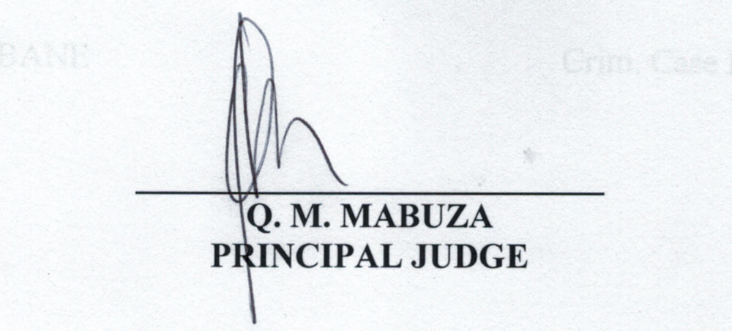For the Applicant: Mr Xaba
For the Respondent: Mr Sithole

