
IN THE HIGH COURT OF ESWATINI

HELD AT MBABANE CIVIL CASE NO. 57/2021
In the matter between:

NTOMBI NOLWAZI GULE APPLICANT

And

SANELE RICHARD MASHWAMA 1ST RESPONDENT
NATIONAL COMMISSIONER OF
THE ROYAL ESWATINI POLICE N.O. 2ND RESPONDENT
THE ATTORNEY GENERAL 3RD RESPONDENT

Neutral Citation: Ntombi Nolwazi Gule vs Sanele Richard Mashwama and 2 Others (573/2021) [2021] SZHC 109 (06 July 2021)

CORAM: Q.M. MABUZA PJ

DATE HEARD: 11/06/21
DATE DELIVERED: 06/07/21

SUMMARY
Civil Procedure - Spoliation proceedings – Applicant must prove that she was in peaceful and undisturbed possession of merx – has failed to do so – Application dismissed with costs.

JUDGMENT

[1] This is an application wherein the Applicant seeks an order in the following terms:
1. Ordering and directing the 1st Respondent and anyone who may be in possession of the hereunder mentioned motor vehicles:
Make: RENAULT
Registration Number: OSD 565 BH
Engine Number: H5FD403D098346
Chassis Number: VF12R401E53020174
And
Make: VOLKSWAGEN
Registration Number: JSD 442 DM
Engine Number: CAX202028
Chassis Number: WVWZZZ1KZ9W506473
To deliver the motor vehicles to the Applicant.
2. Authorizing the Deputy Sheriff for the District of Hhohho to forthwith seize and take the above-mentioned vehicles from anyone who is in possession of same and deliver it to the Applicant.
3. Directing the 2nd Respondent to assist in the execution and enforcement of the orders above.
4. Costs of suit at attorney and own client scale.

[2] The application is opposed by the 1st Respondent who has raised a point of law and a defence on the merits.

[3] The Applicant and the 1st Respondent have been in a love relationship spanning over a number of years. The Applicant as stated in the Notice of Motion wants two cars, a Renault and Volkswagen returned to her. She says both vehicles belong to her and that she was unlawfully disposed of them by the 1st Respondent.

[4] She says that the 1st Applicant bought the Renault for her as a gift for ease of movement when she fell pregnant with their child.

[5] The 1st Respondent denies that he bought the Renault for the Applicant. It was for her convenience and was primarily for taking care of his child. Its use by her was also conditional upon continuation of their relationship.

[6] He also states that they had an agreement that all his assets that were in her possession would revert back to him if she terminated their relationship, which she did. She denies the existence of the agreement.

[7] She says that the 1st Respondent unlawfully dispossessed her of the Renault at the end of October 2020. He says that she handed the keys voluntarily to him.

[8] Lindiwe Sibisi who deposed to a confirmatory affidavit on behalf of the 1st Respondent says that she (Lindiwe) had just returned to the house at Mhlambanyatsi where the 1st Respondent asked for his car keys from the Applicant and she voluntarily handed them over to him. Thereafter she and the Applicant peacefully proceeded to the bus-stop.

[9] The question which arises is: - was the Applicant despoiled of the Renault? Was it removed from her forcefully or did she hand over the keys voluntarily? In order to answer these questions oral evidence has to be adduced because the dispossession itself raises issues of dispute of fact. It is hardly an issue of reinstating the status quo ante.

[10] In respect of the VW Golf, the Applicant merely states that “same was unlawfully taken away from me by the 1st Respondent when I was in peaceful possession of same since it was bought”. There are two details outstanding such as the date she was despoiled and the circumstances surrounding the unlawful dispossession. She says at paragraph 23 of the Founding Affidavit that she saw the Renault being towed by a tow truck towards Mbabane town and the other car (VW Golf) then followed being driven by one of his workers. The response thereto by the 1st Respondent is a cryptic vehement denial that she was in peaceful and undisturbed possession of the VW Golf and puts her to strict proof thereof.

[11] Regarding the VW Golf, Nkosephayo Mashwama deposed to a confirmatory affidavit for the 1st Respondent. In it she says that the VW Golf has always been in her possession since it was purchased. Apparently it was purchased for her by the 1st Respondent. Her assertion puts the issue of possession in dispute to which oral evidence would be required.

[12] As stated earlier, the 1st Respondent raised a point in law to the effect that the application is fraught with material disputes of fact rendering the matter incapable of a proper determination without the aid of viva voce evidence. This is what the 1st Respondent says:
2.1.1 The material dispute run to the core of the litigation and they were reasonably foreseeable to the Applicant who, however with full appreciation of the likelihood of a dispute of fact arising proceeded to approach this Honourable Court on motion proceedings.
2.1.2 The dispute relates to the ownership of the vehicles and the facts surrounding the passing of possession of same from Applicant to the 1st Respondent and vice vesa and this cannot be resolved on affidavits.

[13] I agree with the 1st Respondent that the matter is fraught with material disputes. In addition the Applicant has failed to discharge the onus placed on her to prove that she was in peaceful and undisturbed possession of both merx.

[14] In the event the application is dismissed with costs on the ordinary scale.

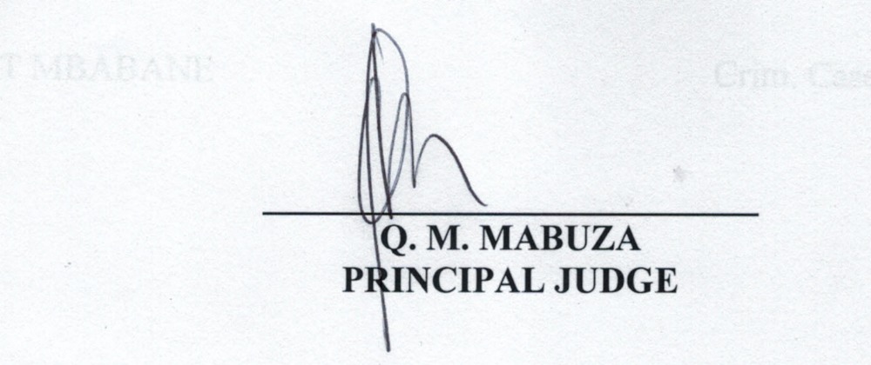
For Applicant : Mr. Ntshangase
For 1st Respondent : Mr. Mngomezulu

