

IN THE INDUSTRIAL COURT OF APPEAL OF SWAZILAND

HELD AT MBABANE CASE NO. 1/ 2017
In the matter between:-
THANDIE KUNENE 1st Appellant
MAKHOSANDILE VILAKATI 2nd Appellant
DAVID NDLOVU 3rd Appellant
And
SWAZI MTN LIMITED Respondent

Neutral citation: Thandi Kunene,Makhosandile Vilakati and David Ndlovu v Swazi MTN Limited (01/2017) [2017] SZIC 03 31st October 2017

Coram: J. MAGAGULA, AJA
D. TSHABALALA, AJA
M. LANGWENYA, AJA

Date of Hearing: 11 October 2017
Date of Judgment: 31 October 2017

SUMMARY
Labour law-unfair dismissal-reinstatement-re-engagement-compensation-import of section 16 (1) and (2) of the Industrial Relations Act 2000-Court’s discretion
______________________________________________________________________________
JUDGMENT
______________________________________________________________________________

M. LANGWENYA, AJA
The appellants were employed as managers in different departments by the respondent until they were dismissed on 30 June 2011. The first appellant was employed on 9 April 2001 and was a procurement and warehouse manager earning a monthly salary of E26,739.75. The second appellant was employed on 27 April 2010 and he occupied the position of MIS/DBA manager and was earning a monthly salary of E37,659.74. The third appellant was employed on 19 January 1999 and occupied the position of service centre manager and was earning a monthly salary of E27,166.70 .
The appellants were dismissed from their employment by the respondent on the basis that their positions had become redundant as a result of a restructuring exercise. The respondent cited modernization and competition as the main reasons for restructuring its operations.
The Respondent is a body corporate registered in accordance with the company laws of Swaziland. The Respondent is a subsidiary of the MTN Group. The Group corporate structure is divided into three categories; namely Tier 1, Tier 2 and Tier 3.When the Respondent was established, it had a ten-year monopoly over the mobile telephone communication industry in Swaziland. The end of the ten year monopoly period of the respondent came with the liberalization of the telecommunication industry in Swaziland-which meant that the respondent had to compete with other role players in the telecommunication sector.
In order to have a competitive edge, the respondent had to modernize and align its operations with Tier 3 operations-a process that was done through a restructuring exercise. The restructuring exercise resulted in appellants’ jobs being redundant as new positions requiring new qualifications were created. The appellants did not meet the new job requirements hence they were retrenched.
The appellants challenged their dismissal in the Industrial court and claimed inter alia for their reinstatement or its equivalent; maximum compensation for automatically unfair dismissal and costs of suit.
On the 18 November 2016 the court a quo found in favour of the appellants and ordered the respondent to compensate the appellants. The court a quo was of the view that since almost five years had passed from the date of appellants’ dismissal, it would be impracticable for them to be reinstated.
Dissatisfied with the judgment of the court a quo, the appellants noted their appeal on the following grounds:
- The court a quo erred in law by refusing to order the respondent to reinstate the appellants and by relying upon the lapse of a period of five years as a reason for not doing so;
  - Contrary to the provisions of section 16 (1) (a) of the Industrial Relations Act No. 1 of 2000; and
  - That the court a quo erred in law and misdirected itself by not applying section 16 (2) of the Industrial Relations Act, 2000 as the exceptions listed in that section contained no stipulated number of years against which a reinstatement order cannot be made.
- The court a quo erred in law and misdirected itself by failing to enforce an undertaking by the respondent to reinstate the appellants notwithstanding whether the positions were available or not.
- The court a quo erred in law by not holding that the appellants’ dismissal satisfied the requirements of section 2 (c) of the Industrial Relations Act, 2000 as amended.

Background
The respondent had a ten year monopoly in the telecommunication industry in Swaziland prior to 2010. The monopoly came to an end when the telecommunication industry was liberalized in Swaziland. In November 2010, the respondent started the restructuring of its operations to position itself to compete with other role players in the telecommunication industry in Swaziland.
The restructuring process resulted in four employees losing their jobs as they could not be accommodated in the new positions that were created. Of the four employees rendered redundant, only one accepted an exit package and left the respondent. The three employees did not accept the exit packages offered and were consequently terminated on the ground of redundancy. The three employees are the appellants.
The court a quo found that the retrenchments were substantively and procedurally unfair. The court found that the retrenchments were substantively unfair because the respondent was not committed to redeploy the appellants to lower positions within the company.
The court a quo held further that the retrenchments were procedurally unfair because the environment within which the consultation process took place was sullied by the respondent who served the appellants with letters advising them to take special leave while the consultation process was ongoing. To the appellants, participating in the consultation process while on special leave meant the respondent had no commitment to retain the appellants in employment.
Another reason retrenchment was deemed to be procedurally unfair by the court a quo was that appellants were dismissed before the final determination of their appeal by the Human Resources and Remunerations Committee. Even though there was no legal requirement for the appellants to appeal, because the respondent granted them the recourse to appeal, the appellants were within their rights to expect the respondent to consider their appeal before their termination.
The Reinstatement and Compensation Conundrum
Section 16 (1) of the Industrial Relations Act (IRA), 2000 as amended provides for the remedies of reinstatement, re-engagement and compensation to employees who are unfairly dismissed from employment. Section 16 (1) of the Industrial Relations Act provides:
If the court finds that a dismissal is unfair, the court may-
- Order the employer to reinstate the employee from any date not earlier than the date of dismissal;
- Order the employer to re-engage the employee either in the work in which the employee was employed before the dismissal or in other reasonably suitable work on any terms and from any date not earlier that the date of dismissal;
- Order the employer to pay compensation to the employee.
An employee who is unfairly dismissed must be reinstated unless one of the exceptions in Section 16 (2) of the Industrial Relations Act applies. Section 16 (2) of the IRA provides that:-
The court shall require the employer to reinstate or re-engage the employee unless-
- The employee does not wish to be reinstated or re-engaged;
- The circumstances surrounding the dismissal are such that a continued employment relationship would be intolerable;
- It is not reasonably practicable for the employer to re-instate or re-engage the employee;
- The dismissal is unfair only because the employer did not follow a fair procedure.
Section 16 (1) and (2) of the Industrial Relations’ Act 2000-Application
According to the above stated section 16 (1) of the IRA, once a court finds that an employee has been unfairly dismissed, the court is empowered to either order the employer to reinstate the employee; or to re-engage the dismissed employee or to pay the dismissed employee compensation. The choice of language by the legislature in section 16 (1) is deliberately permissive as the word ‘may’ is used while in section 16(2) the language is peremptory as the word ‘shall’ is used.
In cases of unfair dismissal the court a quo is empowered to order reinstatement, re-engagement or compensation. Put differently, if an employee is unfairly dismissed he is entitled to be reinstated if there is no evidence preventing a court from making a different order. The court a quo has a discretion to order any of the above-stated remedies but such discretion must be exercised judicially. The essence of discretion is that: ‘if the repository of power follows any one of the available courses, he would be acting within his power’. Ultimately, judicial officers have to assess the facts and decide what is fair and reasonable in the particular circumstances. Unless it can be shown that the court a quo exercised its power in a capricious and unlawful manner, an appellate court should not interfere with such exercise of discretionary power.
It follows therefore that the refusal by the court a quo to order reinstatement on the basis that it would be impracticable as five years had lapsed cannot be faulted since it accords with section 16 (1) (c)-a provision that allows the court latitude to order reinstatement, re-engagement and compensation. In any event, appellants had prayed either for reinstatement, re-engagement or compensation and the court a quo granted the latter. There is nothing, it must be said which prevented the court a quo from granting some, but not all of the relief sought.
The Remedy of Reinstatement Articulated and Applied
Reinstatement is the primary remedy whenever a dismissal has been found to be substantively unfair. The Constitutional Court of South Africa has explained reinstatement as putting ‘the employee back into the job or position he occupied before the dismissal, on the same terms and conditions’. The purpose of reinstatement is to place an employee in the position he would have been but for the unfair dismissal. Reinstatement safeguards a worker’s employment by restoring the employment contract.
Although reinstatement is the primary remedy, it is a suitable remedy only if labour disputes are resolved expeditiously which was not so in the present matter. This matter was concluded almost five years after the appellants were dismissed. This scenario is not peculiar. The result is that reinstatement as the primary remedy is not strictly enforced as such by labour forums.
According to section 16 (2) (c) reinstatement will not be ordered if it is not reasonably practicable for the employer to reinstate or re-engage the employee. This is an exception to the general rule that reinstatement may be ordered. The practicability of ordering reinstatement depends on the particular circumstances of the case, but in many instances, the impracticability of resuming the relationship of employment will increase with the passage of time.
In the Republican Press (Pty) Ltd CEPPWAWU and Others (2008) ISA 404 (SCA) case, the Supreme Court of South Africa held that the passage of six years from the date of dismissal rendered an order of dismissal “not reasonably practical”. In this case, the employees were unfairly retrenched and six years passed due to protracted litigation. The SCA held that although reinstatement was the primary remedy in law it was inappropriate under the circumstances because the employer had outsourced the concerned jobs and also further restructured the business and retrenched.
However, the fact that a long period of time has elapsed since the dismissal of the employees does not necessarily constitute a basis to deny them reinstatement, (See generally Mzeku v Volkswagen SA (2001) 3 BAR 256 (CCMA); Sidumo and Another v Rustenburg Platinum Mines Ltd and Others 2008 2 SA 24 (CC) where reinstatement was ordered seven years after dismissal. Each case must be decided on the basis of its particular circumstances.
Where the delay in the finalization of a labour dispute is a result of any fault or unreasonable conduct on the part of the employer it would be appropriate to order reinstatement.
A brief chronology of events leading to the delays in this matter is that: the appellants were dismissed on 30 June 2011 but only instituted proceedings in the court a quo on 3rd August 2012. This delay is attributable to the appellants. The matter was only put in the court roll of the Industrial Court in February 2016. This delay can neither be ascribed to the appellants nor to the respondents. The subsequent postponements including requests by respondents’ counsel to enable him to be on time to catch his flight at the airport were a result of indulgencies agreed upon by both counsel.
Since the delay in the finalization of the matter in the court a quo cannot be attributable to the respondent, the authority of the case of Billiton does not apply to this case. For as many times as the matter was postponed during the trial stage, both parties agreed to the postponements.
Re-engagement-Meaning and Application
It was argued on behalf of the appellants that the court a quo erred by not considering the alternative of re-engagement of the appellants. The IRA defines re-engagement as:-
An action or situation whereby the employee is engaged or re-engaged by the employer in the same or comparable or identical work to that which the employee was engaged in before the termination or purported termination of the employee’s work or service or employment, or such other reasonably suitable work or employment, from such date and on such terms or employment as may be agreed upon by mutual consent or by order of the court or of an arbitrator.
Re-engagement, like re-employment implies termination of the previous employment contract and the creation of a new employment contract. In (see Transnamib Holdings Ltd v Engelbrecht the court stated that the principal difference between the concepts is that the reinstatement relates to the identical job, while re-employment relates to a similar job.
Reinstatement can be distinguished from re-employment in that reinstatement restores the original contract whereas re-employment creates a new contract (see RD Sharrock “Business Transactions Law” (2011) 489; see also Equity Aviation Services (Pty) Ltd v CCMA and Others). These authorities state that re-employment implies termination of a previously existing employment relationship and the creation of a new employment relationship, possibly on different terms both as to the period and the content of the obligation being undertaken.
It was the appellants who prayed for reinstatement, maximum compensation for automatically unfair dismissal, costs of suit, and further and/or alternative relief. There was nothing therefore which prevented the court a quo from granting some, but not all of the relief sought.
Compensation
Section 16 (2) of the IRA states that if continued employment would be intolerable or if it has become impracticable to take the unfairly dismissed employee back into the post that he had previously filled, compensation should be ordered. Determining whether or not this is the case is left to the presiding officer to assess. It is not only the employee who has to be considered. Swaziland’s labour legislation is not solely concerned with the attainment of fairness for employees. The interests of employers are equally important to ensuring a sound economy.
The court a quo came to the conclusion that compensation and not reinstatement was the appropriate remedy for the appellants. I find no merit in appellants’ rejection of the award of compensation in preference for reinstatement as much as appellants had claimed the remedy of compensation in the alternative.
Order
Accordingly, the court makes the following order:
The appeal is dismissed with costs.

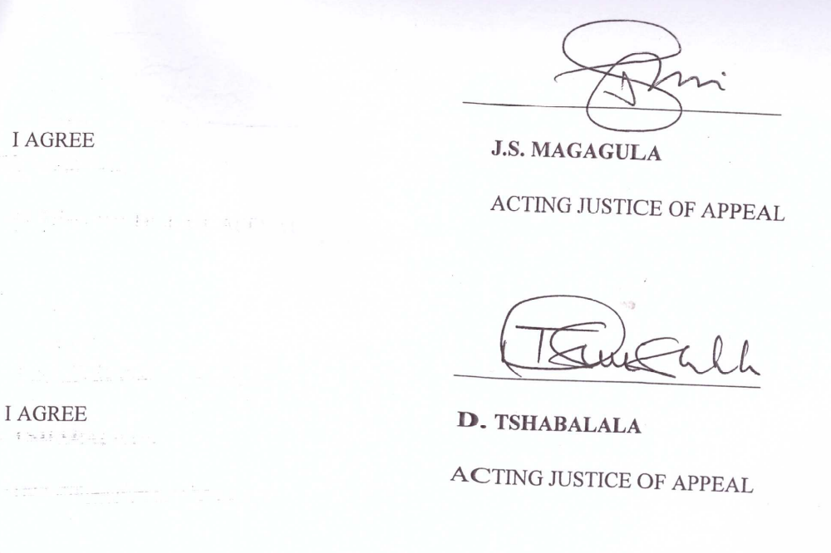

For the Appellant Attorney M.P. Simelane
For Respondent Advocate A. Snider (Instructed by M. Sibandze)

See Page 12, paragraph 5.10 of the Record of appeal.
Tier 1 consists of the big operations of Nigeria and the Republic of South Africa, tier 2 is made up of the medium size operations found in Cameroon and tier 3 are the small size operators like the kingdom of Swaziland and the Republic of Rwanda.
See Perumal v Tiger Brands (2007) 28 ILJ 2302 (LC) at paragraph 35.
See National Union of Mineworkers and Others RSA v Geological Services a division of De Beers Consolidated Mines Ltd (2004) 25 ILJ 410 (ARB).
See NUMSA and Others v Fibre Flair CC t/a Kango Canopies (2000) 6 BLLR 631 (LAC).
See Equity Aviation Services (Pty) Ltd v CCMA and Others (2008) 12 BLLR 1129 (CC) at paragraph 36
See Sidumo v Rustenburg Platinum Mines Ltd (2007) 28 ILJ 2405 (CC) at paragraph 44; see also Vetorri 2013 SA Merc LJ 245.
See Tshongweni v Ekurhuleni Metropolitan Municipality (2012) 33 ILJ 2847 (LAC) at paragraph 33; see also Kroukan v SA Airlink (Pty) Ltd (2005) 26 ILJ 2153 (LAC) paragraphs 117, 118.
See Republican Press (Pty) Ltd CEPPWAWU and Others (2008) ISA 404 (SCA) at paragraph 20.
See Billiton Aluminium SA Ltd t/a Hillside Aluminium v Khanyile 2010 BLLR 465 (CC)
Namibia, at page 1403 paragraphs C-F.
See RD Sharrock “Business Transactions Law” (2011) 489; see also Equity Aviation Services (Pty) Ltd v CCMA and Others.
See Mzeku v Volkswagen SA (Pty) Ltd (2001) 22 ILJ 1575 (LAC) paragraphs 77-79.

