
IN THE INDUSTRIAL COURT OF APPEAL SWAZILAND

HELD AT MBABANE CASE NO.05/2017

In the matter between:

THE GOVERNMENT OF SWAZILAND Appellant

And

SWAZILAND NATIONAL ASSOCIATION
OF GOVERNMENT ACCOUNTANCY
PERSONNEL Respondent
NEUTRAL citation: The Government of Swaziland v Swaziland National Association of Government Accountancy Personnel [05/17] [2017] SZICA 04 31st October, 2017
CORAM: C.S. MAPHANGA, AJA
D. TSHABALALA, AJA
M. LANGWENYA, AJA
HEARD:
DELIVERED: 31 October 2017

SUMMARY - Civil Appeal – Civil Contempt Proceeding permissible only permissible where order sought to be enforced is ad factum praestandum and not ad pecuriam solvendam – Issue whether order directed against the Respondents was in form of a final and definitive imperative ad factum praestandam – Held order issued by Court a quo at first instance short of requirements of a final and definitive orders ad factum praestandam – Appeal upheld

JUDGMENT

[1] This is an appeal from a judgment of the Industrial Court (the Court a quo) in terms of which the Acting Accountant General Ms. E.N. Matsebula was held to be in contempt of court and was thereby ordered to purge her contempt within 30 days failing which the Respondent presently, the Swaziland National Association of Government Accountancy Personnel (SNAGAP) would be free to apply for her committal to jail.

[2] It is necessary to briefly recount the history of the matter leading to the civil attempt proceedings which has given rise to the present appeal. To this end we have relied on the synopsis of the background facts as outlined by the court of first instance.

[3] The Respondent is a public sector union representing public service employees drawn from the accounting profession within the service. It appears that the Respondent had engaged the Government of Swaziland in a course of negotiations pertaining to a dispute that emerged over the review of service terms and conditions affecting the accountancy sector. These bilateral negotiations culminated in certain agreements being reached in June 2012 the result of which was the approval of a proposed Scheme of Service. That document came to be referred to a quo as the Amended Scheme of September 2009.

[4] The original source of discord between the parties is that the appellant had caused to be published by way of a Government Circular No.1 of 2014 a new Schemes of Service document in terms it sought to introduce certain novel terms and conditions of service and personnel grading structure that had not formed part of the approved scheme and as such had not been agreed upon.

[5] The bone of contention was that the appellant had been seen as attempting to unilaterally impose these new conditions without the concurrence and collective agreement with the Union. Specifically the Union objected to the insertion of certain provisions in the Schemes of Service which would have the effect of altering the structure and stratification of certain title posts in the accounting sector. A part of the innovation wrought by the new schemes was a process in terms of which certain positions in what is termed the accounting and stores cadre would be separated or categorized into two streams distinguishing between personnel who held certain levels of qualifications and those who did not. It also emerged from the background that this process of stratification or double –streaming would result in certain disparities in remuneration levels between these categories. This process has been referred to as double-streaming in the proceedings before the court a quo.

[6] Thus a dispute emerged on account of the Respondents objection to the implementation of the 2014 Schemes of Service and in particular to the double-streaming provisions thereof and the attendant programme the new structure sought to introduce.

[7] The publication of this scheme led to the Respondent Swaziland National Association of Government Accounting Personnel bringing an urgent application before the Court a quo to bring the new scheme to a halt. Although litigation of the parties has had a long tail.

[8] I shall refer to this application as the original application. It was brought under case no.489/2014 and in the covering Notice of Application the Respondents sought the following substantive orders:

a)“Directing the 1st and 2nd Respondents (being the Minister of
Public Service and the Accountant General respectively) to
implement the amended Scheme of Service of September 2009
as per resolution of 21st June 2012.

- declaring that the double - streaming into categories of title posts in the accounting cadre to be null and void and should be set aside.

- that the amended Scheme of Service dated September 2009 be with effect from 21st June 2013”

[9] That application came to be heard before Justice T.A. Dlamini in the Industrial Court and on the 26th March 2015 the Court made the following orders:

- The dispute of the parties relating to double-streaming into categories I and II of the title posts in the accounting cadre is hereby referred to the Conciliation, Mediation and Arbitration Commission for mediation by the Executive Director together with one of the Senior Commissioners within 30 days of the granting of this order. Thereafter the Executive Director is to file a report with this Court in the process and its outcome within 14 days after completion of the process. In the meantime though, the Court directs that the status quo be and is hereby maintained.

- Whatever the outcome of the mediation process in terms of Order (A) above, the implementation date of the 2014 circular shall remain as the 01st April 2014.

- The court makes no order as to costs.

[10] It is common cause that in accord with the order of the court referring the central issue concerning the double-streaming to CMAC, the commission duly facilitated the mediation process between the parties at the conclusion of which an agreement was procured under the title “Memorandum of Agreement” dated 11th May, 2015.

[11] That agreement came to be placed before the Court a quo in circumstances that are far- cry from what the honourable Court had ordered in terms of order A of its judgment of 26th March 2015. It became the subject of further contention in the subsequent proceedings for contempt of court before it wherein the Respondents were seeking to enforce another feature of the courts’ earlier orders. I shall come to these circumstances momentarily.

[12] On the 1st July 2016 the Accountant General (2nd Respondent appearing as a quo) issued and caused to be published a Memorandum communicated generally to the Public Service in terms of which, adverting to the Conciliation Mediation Arbitration Commission Memorandum Of Agreement, she announced that the effective date of conversion of the categories of employees who had undergone the customized course and training would be the 01st May 2016. This was presumably in furtherance of item 4 (c) of the Memorandum of Agreement which provided as follows:

(c) “ The conversion of those employees to the Schemes of Service for the Accountancy and Stores Cadre shall be fully implemented 1st May, 2016.”

[13] Aggrieved by this Memorandum the Respondents protested to its publication which the Respondents perceived as being contrary to and in defiance of the Court Order of the 26th March 2016 with particular reference to paragraph “B” of that order to which that
“ whatever the outcome of the mediation process in terms of Order
- Above, the implementation date of the 2014 circular shall remain April 2014.”
[14] It was in the context of these events and the emerging differences between the parties as to the implementation of the effective date of the conversion of the second group of employees and accrual of scales and benefits commensurate to the Scheme of Service for the Accountancy and Stores Cadre, that the matter came before the Court a quo in the form of the contempt proceedings.

[15] Before dealing with issues arising in this appeal in relation to the contempt proceedings a quo, it is important to comment briefly on a preliminary objection made by Mr Simelane who appeared for the Respondents to the inclusion of and reference to a document which appears in the record under the caption “transcript”.

[16] The Appellants in compiling the record had included at pages 80-95 a certain document a certificate of a transcriber. The certificate is dated 8th May 2017. It is clear that this document was generated in preparation for these proceedings. It comprises of two series of typed pages of what appears to be a transcript of proceedings. It bears the title Industrial Court of Swaziland under the Case No.238/2016.

[17] We have great difficulty in having regard to this document in so far as its status and the proceedings it relates to is unclear. It is a record of court proceedings it is also unclear what it signifies as it is not a judgment or order of the court. For these reasons and also for the fact that it has not been included into the record by consent we have not had taken into consideration herein.

[18] In March the Respondent brought the civil contempt application and in the outcome, the Court a quo on the 28th March 2017 held the Accountant General in contempt and ordered her to purge her contempt within 30 days of delivery and delivery of the judgment at the pain of committal to jail should she fail to so purge her contempt.

[19] It is this order that has given rise to the present appeal.

[20] Notably the Appellants for reasons that remain obscure have in bringing this appeal altered the designation of the parties in that the citation of the various respondents a quo appears to have been substituted with the Government of Swaziland.

[21] The Appellant has raised two grounds of appeal namely that:-

“1. the learned Judge a quo erred in law and in fact by holding that the
implementation date of the scheme of service dated September 2009
remained the 1st April 2014 for those employees who did not have the
requisite qualifications but who were yet to acquire the qualification on the 1st April 2014;
2. that the learned judge a quo erred in law and in fact by pronouncing
on the contempt of court proceedings yet this matter was one that called for the interpretation of the judgment of Dlamini T, delivered on the 26th March 2015, as per the observation of Dlamini T on the 30th January 2017”.

The Legal Principles.
[22] It is a well-worn basis principle in civil proceedings that contempt proceedings are a permissible and appropriate as an enforcement mechanism only where the order sought to be enforced only where the order sought to be enforced is one ad factum praestandain (an order for a person to do, or refrain from doing a certain thing) and not pecuniam sovendam ( for the payment of money) see

[23] That is the first key principle that bears consideration is a matter such as the one that presented before the Court a quo.

[24] Once this requirement has been met a court dealing with civil contempt proceedings has to further ascertain and establish that such an order (ad factum praestandun) exists and was issued before committal of the person accused of contempt.

[25] Further it must be established that the said order was served on that person or that he or she was aware of such an order but failed or neglected to abide by or comply with the said order and that the failure to comply was intentional.
(See Fakie No. v CCI Systems(Pty) Ltd 2006 (4) SA 326 (A).

[26] As to what constitutes an order or judgment in the general sense, I would turn to certain remarks by Harms AJA (as he then was) in Zweni v Minister of Law and Order 1993 (1) SA 523 (A) at paragraph 8 when he defined a judgment or order as
“a decision which as a general principle, has three attributes, first the decision must be final in effect and not susceptible of alteration by the Court by first instance; second, it must be definitive of the rights of the parties ; and third, it must have the effect of disposing of at least a substantial portion of the relief claimed in the main proceedings) Van Streepen and Germs (Pty)Ltd v Transvaal Provincial Administration 1987 (4) 569 (A) at 5861 I – 587B ; Marsay v Dilley 1992 (3) SA 944 (A) v Villey 1992 (3) SA 944(A) at 962 C-F). The record is the same as the oft-stated requirement that a decision in order to qualify as a judgment or order, must grant definite and distinct relief (Willis Faber Enthoven (Pty) Ltd v Receiver of Reveune and Another 1992 (4) SA 202 (A) at 214 D-G”
(my emphasis by underscore)

[27] In this context the consideration of the contempt proceedings a quo turn on one basic and crisp question whether in relation to the contempt allegation there was, obtaining against the alleged contemnor, an order in the sense of a writ directed to the 2nd Respondent (or appellant) to or refrain from doing a definite and distinct thing and thereby granted the Respondent definite relief.

[28] It goes without saying that without the existence of an order ad factum praestandum against the Appellants there could be no talk of contempt. It must be shown that there was a clear and definite order directing or enjoining her to do or desist from doing a certain thing.
[29] It is common cause that in the course of the application before the court an order a quo sitting in the first instance under case no. 238/2016, the Union had sought, inter alia, “directing the Minister of Public Service and the Accountant General to implement the Scheme of Service by September 2009 as per resolutions by 21st June 2012”

[30] However in its decision the Court a quo dismissed this prayer. It made no specific order directing any of the respondents as regards the implementation of the Schemes of Service but on the contrary after referral of the underlying latent issues to CMAC ordered that

“In the meantime …the court directs that the status quo be and is hereby maintained”.

[31] It is also vital to note that the court a quo went on to conclude that “whatever the outcome of the mediation process in terms of Order (A) above, the implementation date of the 2014 circular shall remain as the 01st April, 2014 (sic)”. Still the Court a quo did not issue a mandatory order against the 2nd Respondent, the party whose committal for contempt is sought. It appears to us that the court overlooked this important crucial element upon finding the 2nd Respondent in contempt.

[32] There is another difficulty presented by the initial judgment by the court a quo which the contempt proceedings are ostensibly intended to enforce. This arises from the referral of an aspect of the dispute before the court to mediation.

[33] It is clear from the order of the court that what the learned judge did was hold over or stay the matter pending the conclusion of the mediation process and the filing by the Executive Director of a report on the outcome of the mediation back to the court.

[34] It can be surmised that the court probably had in mind that upon the filing of that report it would then make a final and definitive order. That step appears to have been leapt over by the Respondents contempt proceedings a quo. It appears to us that step was not only premature but irregular.

[35] By all accounts and on the facts the only definitive order the court a quo did make in its judgment of the 26th March 2015 was direct that

“the status quo be and is hereby maintained”.

[36] It is our considered view that the first and foremost requirement for civil contempt relief ; that of showing there was a clear and unequivocal order by the court directed at the Accountant General carry out a specific action or course of action ; has not been fulfilled.

[37] We note and are mindful that there was a debate during the submissions as to whether the orders of the court a quo of the 26th March 2016 were clear and unequivocal and whether it was susceptible for interpretation. It is not necessary for this court to venture into these issues.

[38] For the reasons stated herein it is clear that there can be no basis for the contempt proceedings and accordingly the appeal must succeed. We further order that the matter be remitted back to the court a quo in accordance with the process as envisaged in Paragraph (A) of the court orders to enable the court to finalise the matter.

[39] In the outcome this appeal succeeds.

It is ordered that the matter be remitted to the court a quo upon filing of the outstanding report by the Executive Director of the Conciliation Mediation and Arbitration Commission.
We make no order as to costs.

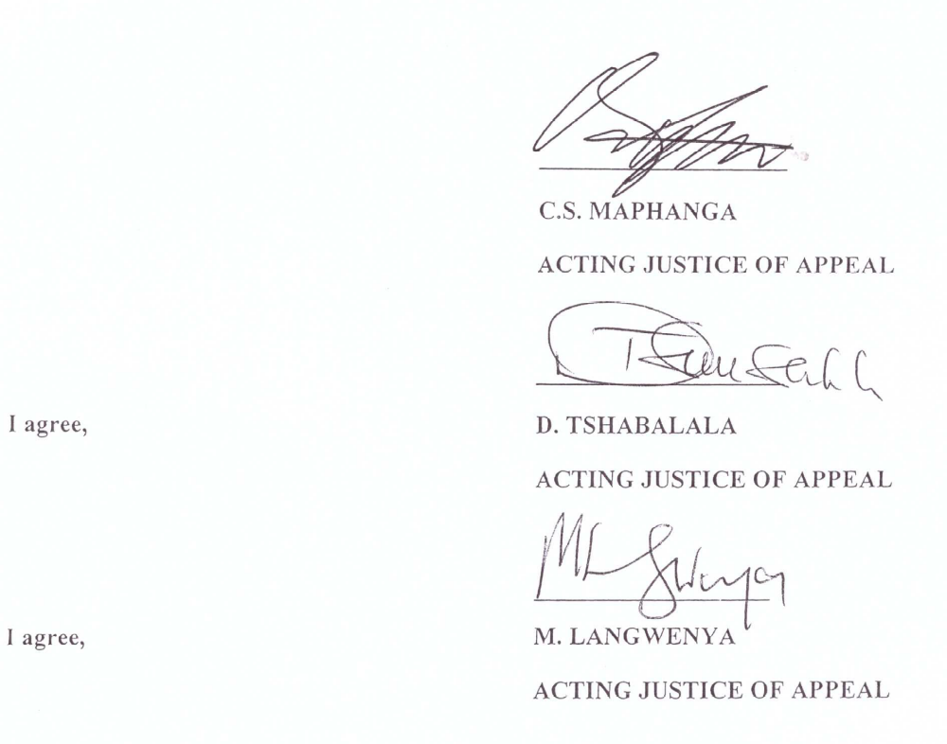

FOR APPELLANT: N. XABA
FOR RESPONDENT: M.P. SIMELANE

This appears at page 32 of the Record

