

IN THE SUPREME COURT OF SWAZILAND

JUDGMENT

Civil Case No. 41/2017
In the matter between:

LOMCEBO S. DLAMINI Appellant
And
VUSI SIBISI Respondent

Neutral citation: Lomcebo Dlamini v Vusi Sibisi (41/2017) [2017] SZSC 39 (10 November 2017)

Coram: DR B.J.ODOKI JA, S.P. DLAMINI JA and M.J. DLAMINI JA

Heard: 25 September 2017
Delivered: 10 November 2017

Summary: Civil law – Damages arising out of a motor vehicle collision – Whether negligence proved or not – Whether contributory negligence proved or not – Whether the defence of sudden emergency is proved or not – Held that negligence was proved against Respondent and that there was no contributory negligence on the part of the Appellant, – Held that the defence of sudden emergency was not proved – Held that the appeal is upheld and the judgment of the Court a quo is set aside.

JUDGMENT
S.P. DLAMINI JA

[1] This is an appeal against the judgment of the Court a quo whereby the Appellant’s claim was dismissed with costs.

[2] In 25 March 2004, Appellant instituted action proceedings against the Respondent. In the particulars of claim, inter alia, the Appellant alleged the following;
2.1 that on the 21 October 2002 her vehicle was parked along the Golf Course Road and near the Christian Life Centre Church situate at Eveni area;
2.2 that Respondent negligently caused a motor vehicle he was driving to collide with her stationary motor vehicle; and
2.3 that as a result of the said collision, her motor vehicle was extensively damaged and the repairs to put her vehicle in condition at was in before the collision cost E54,394.14 and that Respondent was liable to pay her this amount.

[3] The Respondent denied the liability alleged by the Appellant and pleaded;
[3.1] that the doctrine of sudden emergency applies in that he was disturbed by an oncoming vehicle which was driven on his side of the road and in avoiding a head–on collision he had no option but to collide with Appellant’s stationary vehicle; and
[3.2] that in the alternative, the Apportionment of Damages Act applies in that Appellant was negligent by parking her car on the road reserve and caused or contributed to the damage of her car.

[4] As it appears in the papers before Court, this matter experienced some delays. Firstly, while the collision occurred in 2002, Appellant only instituted proceedings in 2004. The reason for this could be that it appears some efforts were made to settle the matter out of court prior to the issuing of summons. Secondly, the trial commenced before the Court a quo on 21 October 2015 and the matter was heard on three different dates in 2015 and 2016. Judgment was delivered on 4 April 2017.

[5] After consideration of the issues, the Learned Judge as per paragraphs [96], [97] and [98] of the judgment concluded that;
“[96] In the event I find that it was the Plaintiff’s negligent parking that led to the collision. It is my further finding that the Defendant was not negligent at all. He was faced with a sudden emergency and drove his motor vehicle to a place of safety but alas the Plaintiff’s motor vehicle blocked his safety exit.
[97] Having found that the Plaintiff was the author of her own misfortune, there will be no need for me to make any finding with regard to apportionment of damages.
[98] In view of the aforegoing, the Plaintiff’s claim is dismissed with costs.”

[6] The Appellant being dissatisfied with the judgment of the Court a quo launched the appeal before this Court.
[7] Prior to the hearing of the main appeal, this Court considered and decided applications by both parties seeking condonation for the late filing of the Heads of argument and bundles of authorities.

[8] The Respondent’s application for condonation was not opposed by the Appellant under the common mistake that because the Appellant had not filed her Heads of argument and bundle of authorities, the Respondent was excused in not complying with relevant time stipulated in the Rules. This is clearly wrong. The correct approach is that the Respondent was not excused and ought to have filed his Heads of argument and then seek to supplement them at later date if it turns out that there is a need to do so due to the late filing by the Appellant. Nevertheless, the Court granted the Respondent’s application for condonation in the interests of bringing this matter to finality.

[9] The Appellant’s application for condonation was opposed by the Respondent. The Court had considered the delay and reasons given for not filing the Heads of argument and the bundle of authorities timeously as well as the other requirement and has exercised its discretion in favour of granting Appellant’s application for condonation on the same basis of condoning the Respondent’s late filing. This matter raises very important legal issues and to dismiss the appeal without dealing with the substantive issues raised would not be in the interest of justice. In addition the Heads of argument were already before the Court and it appears Respondent had been served and therefore no prejudice was suffered by the Respondent. This Court is not remotely suggesting that non-compliance with the Rules will be tolerated. See Appeal Case No. 20/2005 Alton Ngcamphalala and 3 Others v The King at page 2 where His Lordship Justice Tebbut said the following;

“In its inherent jurisdiction this Court mero motu may excuse any party from strict compliance with any of its rules if there is no prejudice to any other party, (see HERBSTEIN AND VAN WINSEN : The Civil Practice of the Superior Courts in South Africa 3rd Edition page 19-20). That is clearly the position here. Each party knows full well what the other party's case is; each came prepared to meet the other's case and even though each one may have not strictly brought its case in the manner prescribed by the rules, this Court will condone that. The matter must be decided on the merits of the matter and the principles applicable to them and not on some inconsequential technical procedural defect.”
[10] Coming to the main appeal, in the Notice of Appeal, the Appellant raised eight grounds of appeal. Seven of the grounds essentially deal with the finding of the Court a quo that Respondent was not negligent and that the defence of sudden emergency was proved. The remaining and separate ground of appeal deals with the rejection by the Court a quo of Appellant’s contention that Respondent admitted liability prior to proceedings.

[11] When all is said and done, the crux of the matter turns on whether the defence of sudden emergency was proved or not. If the defence was proved then the matter including the other issues namely contributory negligence require no further consideration, on the one hand. If the defence of sudden emergency was not proved then the Respondent was negligent and liable for the damage to Appellant’s car, on the other hand. However, it must then be determined whether there was contributory negligence on the part of the Appellant.

[12] At this juncture, it is appropriate to reproduce the Respondents version of the events as per the Court a quo’s judgment. In paragraphs [45] to [54], the judgment states that;
“[45] The defence opened its case with the Defendant Mr. Sibisi giving evidence. He testified that during 2002, he was involved in a car accident while driving along Mantjolo Road (Golf Course Road). He was driving in a BMW SD 888 LG towards Mbabane City. He was alone.
[46] He stated that after the Eveni turn off there is a curve to the left when coming to Mbabane town.
[47] The Court confirmed the curve when it carried out an inspection in loco on site.
[48] The Defendant says that it was dark and he had his headlights on. That as he was approaching the curve there was an oncoming vehicle. That he dimmed his lights but the headlights of the other vehicle came straight at him. He realized that the oncoming vehicle was cutting the corner or curve and by so doing was encroaching onto the Defendant’s lane.
[49] That the encroachment created a sudden emergency for him which required fast thinking on his part in order to avoid a head on collision. That he swerved left out of the road because that was the only alternative available to him at that point.
[50] That his intention was to swerve off the road and return to his lane once the oncoming vehicle had passed or stopped. Indeed he swerved left but there were cars parked there. The oncoming vehicle never stopped and as he was swerving back onto the main road, he hit the stationery cars.
[51] He says that there was no public lighting where the cars were parked; it was dark and made darker because he had dimmed his lights and he did not know the range of his dimmed lights.
[52] He says that he eventually came to a standstill after the impact and some people came out from a nearby church where the Plaintiff was attending a service.
[53] The people assisted him out of his vehicle whose windscreen had broken and some glasses had shattered onto him.
[54] He says that the police later arrived and he told them what he had just told the Court in his evidence in chief.”

[13] Prima facie, to collide with a stationary object is a legitimate basis to infer negligence on the part of a driver but this can be rebutted by the evidence. Respondent sought to rebut the prima facie evidence of negligence through the defence of sudden emergency. It is trite law that he who alleges a special defence must prove it. Therefore, it stands to reason that Respondent carried the burden of proving his defence.

[14] That the doctrine of sudden emergency is part of our law is settled. In the case of BESWICK V CREWS 1964(3) SA (E.C.A) at page 747, His Lordship Justice Van Der Riet stated that;
“There is recognised in our law a doctrine that where a motorist is faced with a sudden emergency he may be excused from liability if under the circumstances he acts to the detriment of another under an error of judgment. But it is a sine qua non of such excuse that he himself in no way contributed to the emergency. See for example the authorities set out in Macintosh & Scoble on Negligence in Delict at p.345.”
(See also the case of Charles Dlamini & Others vs Motor Vehicle Accident and Civil Case 3490-1/97 (High Court of Swaziland).

[15] In the case of Goode v SA Mutual Fire & General Insurance Co Ltd 1979 (4) SA (TPD), His Lordship Justice King stated the following;
“The doctrine of sudden emergency was stated as follows in Thornton v Fismer 1928 AD 398 at 412:
“A person who, by reason of another’s want of care or some unforeseen external contingency, finds himself in a position of imminent danger cannot be guilty of negligence merely because in that emergency he does not act in the best way to avoid that danger.”
There are limitations to this doctrine. Firstly, the doctrine of sudden emergency applies only when a party’s conduct has been prima facie negligent (vide, Van Staden v Stocks 1936 AD 18). In this matter the defendant has relied on sudden emergency. In consequence the defendant has, in effect, conceded negligence but has pleaded that the judgment exercised by the driver of the insured vehicle was an error of judgment in the agony of the moment, or his conduct was reasonable and justifiable.
The other qualification to the rule is that the conduct of the person setting it up must, of course, be reasonable, for the principle that a person in the agony of a moment is not expected to act with the same judgment and skill as in normal circumstances must not be extended to excuse conduct which, even in a critical situation, is not reasonable (vide,Van Staden v May 1940 WLD 198). It is not, therefore, every error of judgement which is excusable as not amounting to negligence, but only one which a reasonably careful and skilled driver of a vehicle might commit. There can only be a moment of agony if the person whose conduct is in question had neither the time nor the opportunity to weigh the pros and cons of the situation in which he found himself.”
(See also Palm v Elsley 1974(2) SA(C.P.D.)

[16] The Respondent, by his on admission, was driving at an excessive speed before the alleged other vehicle came into the picture. Infact, it can be that the high speed can also be inferred from the force and damage caused to both vehicles by the impact during the collision. Therefore, the defence of sudden emergency is not open to the Respondent. Clearly, he could not control or bring the car to a stop.

[17] Furthermore, it can also inferred from the evidence that the Respondent was not only driving at an excessive speed but he was not keeping a proper look out too. He claimed that he could not see the cars that were parked on the side of the road near a church while the service was going on. According to his version, he only saw the cars when he tried to swerve out of the road. He swerved back to the road and then swerved out of the road again ostensibly to avoid a head-collision with an oncoming vehicle thus causing the collision with Appellant’s vehicle.
.
[18] Now having considered that the Respondent was in fact negligent and the defence of sudden emergency was not open to him, the question becomes whether there was contributory negligency on the part of the Appellant by parking her car on the side of the road. There is no sign allowing or disallowing parking on the spot where the Appellants’ vehicle was parked.

[19] Mr Nxumalo, a civil engineer of the Mbabane Municipality was called as a witness by the court. He testified about the purpose of the gravel portion of a road reserve. I suppose in consideration of his evidence the learned Judge in the Court a quo in paragraph [90] of the judgment concluded that;
“A road reserve is not for parking but for public travel. This particular road reserve is immediately after a gentle curve for use in emergencies as the Defendant found himself in, in order to avoid an oncoming vehicle which had encroached on his lane because it probably was cutting a corner.”

[20] It is common cause that motorists do stop or park vehicles on the side of the road frequently for various reasons. The evidence of Mr Nxumalo in my view is of no assistance at all. It is a fact that the Appellant’s vehicle was parked outside the road. To conclude that since her vehicle was parked in the road reserve, it automatically amounts to negligence on her part as the Court a quo concluded, in my view it is erroneous. What if her vehicle had stopped there due to a mechanical fault or some other eventuality? To follow such an approach would result in dire consequences. What if in her vehicle there was a bread-winner who died as result of the collision? His or her dependants would have no remedy at all against the Respondent?

[21] In any event there is no legal basis to establish as to why the Appellant’s vehicle was where it was. It is now settled in our law that in appropriate circumstances even to collide with a stationary vehicle in the middle of the road may constitute negligence or amount to contributory negligence. In these circumstances, a litigant will not escape liability by merely arguing that the other vehicle was stationary in the middle of the road. The rationale here is simply that the other vehicle is stationary in the middle of the road in circumstances that do not constitute any negligence. There could be a person lying in the middle of the road or an accident that has just happened. Surely the other driver in such scenario would still carry the burden of obeying the traffic laws. If for example it can be established that such a litigant ignored warnings about an accident ahead and/or violated the traffic laws and as a result he/she was unable to avoid the collision, the litigant could be found to have been negligent or contributed to the negligence of another.

[22] The version of the Respondent leaves more questions than answers in the following aspects;
- He has no description of the motor vehicle that disturbed him. Was it a sedan or van etc and what colour it was? Yet he was able to see that it was cutting the corner and coming onto his side of the road;
- There is no explanation why the Respondent did not stop his car and put on hazards to warn the oncoming vehicle; and
- Even if the only choice open to him was to swerve out of the road, why did the Respondent not reduce considerably the speed he was travelling at?
[23] It is my view that the Respondent has not discharged this burden. During his cross-examination, the Respondent stated the following as spelt out in paragraphs [63] to [69] of the judgment;
“[63] The Defendant was cross-examined by Mr. Mabuza. The Defendant stated that the time of the accident was about 7:00 pm. in the evening. He stated that even though the right lane was free of obstacles as the oncoming car was on his lane. There was also a small gravel area on the right similar to the one the Plaintiff’s car was on but it was smaller and there was a slope to its right.
[64] When asked why he did not move onto the right lane, he said that he had to make a split decision and he feared that if he drove onto the right lane, the oncoming car might return to its own lane and this would result in a head on collision. He agreed that this would probably have been an alternative route.
[65] He further stated that he first noticed the parked cars on the left side of the tar road after he had swerved off the main road.
[66] He was asked that even though he saw the oncoming lights why did he fail to notice the cars that were parked on the left which were nearer to him.
[67] His response was that he thought that there was a blind spot on that side of the road, there were also shrubs and trees as well as the curve that he mentioned in his evidence in chief. Furthermore, he had dimmed his lights as his focus was on the oncoming lights which were nearer to him and were on full beam.
[68] The Defendant when asked stated that he was travelling at 80 km. per hour even though he knew that the urban speed limit was 60 km. per hour. He says that when he saw the lights of the oncoming vehicle he slowed down.
[69] It was put to him that after impact the Plaintiff’s motor vehicle was pushed 9 paces from where it was parked to where it eventually landed and that this was due to the speed that he was travelling. He disputed that this was due to speed and responded that it should be recalled that the layout of the place including the entrance to the church has dramatically changed since the accident. At the time of the accident the entrance was not paved as it was gravel and had a gentle slope.”

[24] This Court records its concern that the transcript of the proceedings before the Court a quo was not filed with the record yet reference is made to the testimony adduced. The reasons advanced for the Appellant for not filing the transcript are without merit.

[25] In addition, the Police report was not exhibited in this matter yet both parties in their discovery affidavits indicated that it was part of the evidence to be presented before the Court a quo.
[26] Almost invariably, the Police report is essential evidence in road traffic accidents particularly issues of distance, speed, proper look-out and related information is important. In this case this point is clearer because even though the Police report was not admitted, the Learned Judge said the following;
“… . The 4th paragraph in the police report reads as follows:
“Investigation revealed that driver noticed a car coming from the opposite direction cutting a corner, avoiding a collision with that car he noticed two cars in which he knocked both of them he then swerved back to the road, the car skidded thus knocking the two motor vehicles”.
[87] I merely refer to the statement to show consistency and that it was made immediately after the incident and not as evidence because I earlier ruled it inadmissible.”
[27] Despite the concerns mentioned above, the Court is satisfied with the conclusions it has come to on the basis of the evidence before it.
[28] With regard to the damages that Appellant suffered by the Appellant, evidence was led in the Court a quo to substantiate same. In fact the quantum was never challenged. The learned judge in the Court a quo at paragraph [36] stated that;
“David da Silva (PW2) testified that he is an employee of Universal Panel Beaters and has been for twelve (12) years. He repaired motor vehicle VW Polo Player 1.4, SD 849 PG owned by the Plaintiff. The motor vehicle was damaged on the right rear and left front. The quotation was initially for E56,374.14 (Fifty six thousand three hundred and seventy four Emalangeni fourteen cents) (see Exhibit D) but was later adjusted to E54,394.14 (Fifty four thousand three hundred and ninety four Emalangeni fourteen cents). It was repaired for the latter amount on the instructions of SRIC. After it was repaired it was released to the Plaintiff after SRIC paid for the repairs in 4/2/2003. (see Exhibit E).”

[29] Therefore, I am satisfied that the Appellant proved her claim before the Court a quo.

[30] In view of the aforegoing, the Court makes the following order;
(a) that the applications for condonation of the late filing of the Heads of argument and bundles of authorities by Appellant and Respondent are hereby granted and no order as to costs is made in relation thereto;
(b) that the appeal is upheld and the judgment of the Court a quo be and is hereby set aside;
(c) that the order of the Court a quo be substituted with an order “the Appellant is awarded E54 394.14 as damages, interest on the said amount at the rate of 9% per annum a tempore more calculated from the date of issue of summons to the date of final payment and costs of suit” and
(d) that the Appellant is awarded costs.

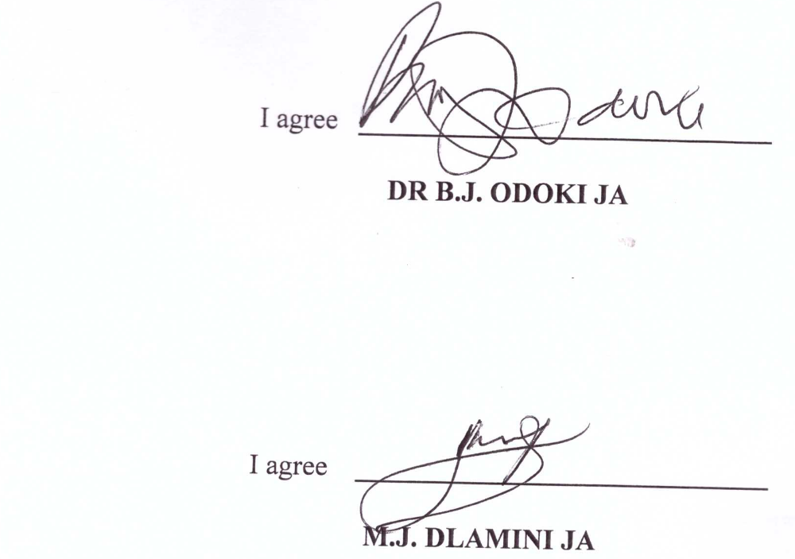
For the Appellant: Miss R. S. Maeda from S. V. Mdladla & Associates
For the Respondent: Mr Thomo from Sibusiso Shongwe Attorneys

