
IN THE SUPREME COURT OF SWAZILAND
JUDGMENT
HELD AT MBABANE CIVIL APPEAL CASE NO: 93/2016

In the matter between:

RHODA MAMBA APPELLANT

And

SWAZILAND SUGAR ASSOCIATION 1ST RESPONDENT
SIBUSISO MOTSA N.O 2ND RESPONDENT
DERRICK JELE N.O 3RD RESPONDENT
VIF LIMITED (IN LIQUIDATION) 4TH RESPONDENT
ROYAL SWAZILAND SUGAR CORPORATION 5TH RESPONDENT
MASTER OF THE HIGH COURT 6TH RESPONDENT
MINISTER OF AGRICULTURE 7TH RESPONDENT
ATTORNEY GENERAL 8TH RESPONDENT

Neutral Citation: Rhoda Mamba v. Swaziland Sugar Association
And 7 Others (93/2016) [2017] SZSC 53 (10 November 2017)

Coram: DR. B.J. ODOKI, JA
S.P. DLAMINI, JA
S.B. MAPHALALA, JA

Date Heard: 3 October 2017
Date delivered: 10 November 2017

Summary: Civil Procedure ‒ Application to set aside decision of Council of the Swaziland Sugar Association made under clause 12 (2) and (3) of the Sugar Industry Agreement ‒ No application to review decision of the Council filed under Rule 54 of the High Court ‒ Whether plough order issued against the Appellant to stop growing sugarcane at Vuvulane and order directing Mhlume Mills to reject sugar cane grown by the Appellant unlawful ‒ Whether new point raised by Appellant unlawful ‒ Whether new point raised by Appellant in founding affidavit that she was not given opportunity to be heard before said orders were made was properly raised ‒ Held that Appellant should have moved application for review under Rule 53 ‒ Appellant should have raised the point that she was not given opportunity to be heard before orders were made in her Founding Affidavit. ‒ No evidence to support estoppel or breach of rules of natural justice by the 1st Respondent ‒ Appeal dismissed with costs.

JUDGMENT
DR. B.J. ODOKI J.A
[1] The Appellant brought an application before the court a quo seeking the following orders;
“3. Ordering that the plough out order issued by the 1st Respondent against the Appellant on 7th April 2015, be hereby set aside.
4. Ordering that the decision by the 1st Respondent directing Mhlume Mill to reject the sugar cane grown by the Appellant at Vuvulane is declared unlawful.
5. Ordering that pending finalization of this application, the applicant be allowed to harvest all sugar cane grown by it at Vuvulane.
6. Ordering that pending finalization of this application 5th respondent accepts for milling all sugar cane grown by the applicant at Vuvulane delivered to it for milling.
7. Ordering that the applicant is allowed to deliver for milling, after every harvest each year sugar cane grown by it to the Mhlume Sugar Mill operated by the 5th respondent”

[2] The applicantion which was filed as an urgent one was accompanied by the relevant certificate of urgency, but it was opposed by the 1st Respondent.
[3] The background to this appeal is as follows. The Appellant is a Sugar cane grower at Vuvulane Irrigated Farms, a portion of farm Number 860, in the Lubombo Region. The 1st Respondent is a body corporate established in terms of section 3 of the Sugar Act, 1967. The portion of the farm utilized by the Appellant is Plot 169 and was originally allocated to her late husband. The allocation was done by the Commonwealth Development Corporation. Currently the farm is owned by the King and Ingwenyama of the Kingdom of Swaziland in Trust for the Swazi Nation. The Appellant was not the only farmer who was given a portion of the farm in question to use.

[4] The use of the farm by the various farmers and their relationship with amongst others, the 1st Respondent had a chequered history. It dates back to about 1980. It has continued unabated and in a very acrimonious manner for most of the times.
[5] The Appellant has about 3 hectares of land on the said farm on which she is allowed to grow sugar cane (quotaed land). However, the Appellant is now growing sugar cane on land measuring about ten times more than the said land. The increase was not approved by the Quota Board of the 1st Respondent. The Appellant claims that there is only one global or unitary quota for all the farmers on the farm.
[6] The provisions of Sugar Act of 1967 (hereinafter referred to as the Act) are binding on all sugar cane growers, millers, refiners and all other persons engaged in the sugar industry in Swaziland. As a sugar cane grower, the applicant is one such person whose activities in the growing of sugar cane are governed in accordance with clause 1 of the Sugar Industry Agreement. Similarly, as a mill operator or miller, the 5th Respondent is governed by the provisions of the Act in the performance of its duties or operations as such.
[7] The Swaziland Sugar Industry Agreement set out in Part 1 of the Schedule together with all amendments thereto forms part of the Act and is binding on “all millers, growers, millers-cum-planters, refiners, and other persons engaged in any aspect of the sugar industry.” (per section 6 of the Act).
[8] During the year 2013, the 1st Respondent advised the Appellant to apply for an increment of the quota of land on which she was growing sugar cane. This was because the Appellant was now growing sugar cane on land which was more than that which had been approved or quotaed by the Association.
The Appellant duly made this application. The application was refused by the 1st Respondent. Despite this refusal, the Appellant continued to grow sugar cane on its increased hectarage or unquotaed land.
[9] By letter dated 7th April 2015, the Appellant was advised by the Secretary to the Council of the 1st Respondent to take out the sugar cane on the unquotaed land. This was followed by a meeting held between the Appellant and the Pest & Disease Control sub-committee of the Council in February 2016 wherein this decision was further communicated to her. As a sequel to the above two events or interactions between the applicant and the 1st Respondent, the latter then advised or instructed the 5th Respondent “to reject with effect from the start of the 2016/2017 Milling season all deliveries of cane from the quota holders” including the Appellant. This was by letter dated 29th March 2016, which was also sent to the Appellant.
[10] In her founding affidavit, the Appellant claimed that the order of the 1st Respondent was disguised as a prevention measure to protect the industry and yet it was only malicious in its nature with intention to cause her financial harm. She also alleged that the actions of the 1st Respondent were intended to destroy her hard earned labour and work.
[11] The court a quo held that if the Appellant was dissatisfied with the decision of the Council of the 1st Respondent it should have filed a proper application for a review of that decision in accordance with the provisions of Rule 53 of the Rules of the High Court.

The court also held that the ground that the Appellant was not afforded an opportunity to make representations to the 1st Respondent was a new ground not pleaded in the proceedings, and therefore could not be raised at this late stage. The court therefore dismissed the application with costs.
[12] Dissatisfied with the above decision of the court a quo, the Appellant has appealed to this court on the following grounds;
“1. The learned judge a quo erred in law and in fact in holding that the Applicant never pleaded that she was never afforded the opportunity to make representation to the 1st Respondent before the latter made, the “plough out” order.
2. The learned judge a quo erred in law in not holding that the failure by the 1st Respondent to afford the Applicant the opportunity to make representation prior to the issuance of the “plough out” order constituted a violation of the “audi, alteram partem” rule of natural justice and thus rendered the “plough out” order invalid by sheer operation of law.
3. The learned judge a quo erred in law and in fact in not holding that the doctrine of estoppel prevented the Respondents from issuing the “plough out” order and rejecting the Appellant’s cane at the sugar mill.

4. The learned judge a quo erred in law and in fact in holding that the Appellant ought to have approached the Court a quo by way of RULE 53 of the High Court Rules in as much as the Rule does not apply where urgent relief is sought or where the Applicant is prepared to forego the record of the proceedings of the entity whose order is sought to be either reviewed or set aside.
5. The learned judge a quo erred in law and in fact in not holding that the “plough out” order was invalid even on the ground that a member of the council of the 1st Respondent (Absalom Themba Dlamini) was disqualified from sitting in the meeting whose proceedings resulted in the “plough out” order being issued as he was already conflicted on the facts.
6. The learned judge a quo erred in law in the fact in placing reliance on the facts as presented by 1st Respondent yet such liligant could only have sourced such facts from the 4th Respondent whom previous judgments of the High Court and Court of Appeal stated that it had no “locus standi” over the land at Vuvulane.

[13] Arguing the first and second grounds of appeal together, counsel for the Appellant submitted that it was a complete misconception of the evidence for the court a quo to hold that the Appellant never pleaded that she was never afforded opportunity to make representation prior to the decision to take out the sugar cane. Counsel referred to paragraphs 33 and 34 of the Appellant’s affidavit where she stated:

“ 33. On or about the 7th April, 2015, I received a letter to the effect that I must plough-out sugar cane I had grown on land not having a quota.
34. We were summoned by the council of the SSA on or about February 2016 to show cause why the plough-out orders must not be carried out and the mill not reject our harvest for milling”
[14] Counsel argued that at paragraphs 40 and 41 of the Answering Affidavit of Banele Nyamane unequivocally admitted the above averments.
[15] Counsel also referred to paragraph 39 of the Appellant’s Founding Affidavit where she stated;
“ 39. Clause 12 (2) (1) provides that the council must cause me to appear
before it on a date not less than 14 days to show cause why I should not plough-out the fields. I submit that 1st Respondent caused me to show cause only in the year 2016 and there it appeared that this was essentially a land dispute and had nothing to do with pests and diseases”
[16] It was counsel’s contention that the essence of the above averments and responses is that not only was it alleged, in fact it was admitted, that the representation came after and not before the decision to take out the cane was made. Therefor the “audi alteram partem” rule of natural justice was clearly violated. Counsel submitted that the plough-out order was invalid on the authority of Swaziland Federation of Trade Unions vs The president of the Industrial Court of Appeal of Swaziland and Another Case No 11/97).

[17] Counsel further argued that even if the point had been raised for the first time during the argument it would have been proper, as such point can be raised at any time before judgment.

[18] On the other hand Counsel for the 1ST Respondent submitted that the paragraphs 30, 34 and 35 of her Forwarding Affidavit indicate that the Appellant and others were advised by the 1st Respondent to apply for increment of the quota concerning the remainder they had ploughed on and she duly lodged an application which she later learnt that it was rejected. On 7th April 2015, the Appellant was advised to plough-out the sugar cane not having quota. In February 2016, the Appellant was summoned to show cause why the plough-out order must not be carried out, and the Appellant did appear before the council. It was counsel’s contention that it was after that meeting with the Appellant that the 1st Respondent wrote, on 29 March 2016, a letter to the Appellant telling her that since she had refused to plough-out her sugar cane, the Mhlume Sugar Mill must not accept her sugar cane. Therefore, counsel submitted, the Appellant was given an opportunity to be heard before the plough-out order was confirmed.

[19] In his judgment, the learned judge in the court a quo held that the ground that the Appellant was not given an opportunity to make representation to the 1st Respondent before the decision to order the Appellant to take out her sugar cane was a new ground not raised in her Founding Affidavit. The court a quo stated.

“[14] In the heads of argument counsel for the Applicant submitted and based his argument or submissions on the ground that Applicant “was never afforded an opportunity to make representation to the first respondent” before the latter made the decision to order the Applicant to take out its cane.
This is a totally new ground which was not pleaded at all in the proceedings herein. Counsel may not change his client’s case at this stage of proceedings by bringing up or raising a totally different cause of action. This is objectionable simply because it is not the case that the respondents have been called upon to meet or answer in this application (vide Muzi Mnisi v The Chairperson Limkokwin University of Creative Technology Disciplinary Committee and Another (443/20167) {2016} SZHe 61 (24 Ranch 2016) and the case cited therein)”

[20] I am unable to fault the conclusion reached by the judge in the court a quo. The point of failure of the 1st Respondent to afford the Appellant a hearing before it took the impugned decision, was not raised in the Appellant’s Founding Affidavit. On the contrary in paragraphs 34 and 35, the Appellant confirmed that she was summoned by the 1st Respondent to show cause why the plough-out order must not be carried out and the mill not to reject her harvest for milling.

[21] The Appellant admits that she made representations at the meeting with the 1ST Respondent in paragraph 35 of her Founding Affidavit as follows:

“35. The outcome of this meeting is that I insisted that the plough-out could not be carried out because a letter from the Inner Council of Vuvulane (Bandlancane) had been attached to the application for increased quota and the water permit attended to earlier is one SSA is fully aware of that .
It was further revealed that I am ready to comply with the pest and diseases regulations and as such since cultivating the land there is no disease that was never identified”

[22] It was after her making representations before the 1st Respondent that the 1st Respondent wrote her a letter dated 29th March 2016, telling her that Mhlume Sugar Mill must not accept her sugar cane ready for harvesting since she had refused to plough-out her cane. This admission is contained in Paragraph 36 of the Appellants Founding Affidavit.

[23] Therefore, there is no merit in the 1st and 2nd grounds of appeal, which must fail.

[24] On the third ground of appeal, Counsel for the Appellant submitted that the learned judge in court a quo erred in law in not holding that the Respondents were prevented by the doctrine of estoppel from issuing the plough-out order and rejecting the Appellant’s cane since they had always dealt with the Appellant and other farmers on the same terms over the years. It was counsel’s contention that there is tangible proof that as recently as 2013, the Respondents have been carrying out soil suitability tests on the very land in question for purposes of ploughing sugar cane; and a favorable report was compiled on 4 February 2013, and this act was inconsistent with the claim by the 1st Respondent that it has been calling upon the Appellant to plough-out the sugar cane that is ploughed in unquoted land to no avail.

[25] Counsel submitted further that the conduct of the 1st Respondent to call the 5th Respondent not to accept the Appellant’s cane, knowing very well that it enjoyed a monopoly of regulating the sugar industry in the country leads to no other reasonable inference than that the 1st Respondent was on a mission to cause considerable financial harm to the Appellant. It was counsel’s contention that this conduct was actuated by ulterior or improper motives aimed at pleasing the 4th Respondent, which showed malice on the part of the 1st Respondent.

[26] Counsels for the 1st Respondent argued that the allegation by the Appellant that the 1st Respondent is malicious is a vague and bold statement without setting out any facts to substantiate the same. Counsel submitted that the 1st Respondent agrees with what the learned judge in the court a quo stated in paragraph [13] of his judgment as follows;

“[13] I have referred in the preceding last two paragraphs to the powers of the Quota Board to demonstrate that even if this application could be viewed as an application for a review of the first respondent’s decision to order the plough-out or take out of the cane grown by the applicant,
the latter would still have failed to satisfy this court that the said decision was arrived at ‘maliciously’ and therefore ought to be reviewed and set aside. The applicant has merely stated that the decision is aimed at financially crippling her business or farming operations. There is certainly no material on which this allegation is made. It is just a bold yet bald allegation that, in my judgment cannot assist the applicant in this case”

[27] In my view the learned judge in the court a quo came to the right conclusion that the allegation of malice against the 1st Respondent had not been established. In paragraph 21 of its Answering Affidavit, the 1st Respondent stated,

“21 …..The 1st Respondent humbly averts that it appears that the Applicant is well versed with the provisions of the Act as well as the agreement but chooses not to comply with the same for reasons best known to her. The Respondent further averts that to further demonstrate its good intentions in dealing with the Applicant is the fact that it has always been accepting the Applicant’s sugar cane and calling upon her to plough-out the sugar cane that it is ploughed in unquoted land to no avail. The 1st Respondent cannot afford to deal with farmers such as the Applicant who does as they please in the industry”

[28] There was no evidence to support the claim of estoppel against the 1st Respondent as counsel for the 1st Respondent submitted. It was apparent that what the Appellant sought was to by-pass the provisions of the Sugar Act and the Swaziland Sugar Industry Agreement by approaching the court on an urgent basis for an order that would allow her to plough and harvest illegally, on land in respect of which increased quotas had not been approved as already requested by her but refused by the Quota Board. The Appellant sought the court to ignore the provisions of the Sugar Act and allow her to act contrary thereto for her own benefit. It is trite law that a court cannot sanction an illegality as to do so would be to undermine the purpose of the legislation. Accordingly ground three must fail.

[29] With regard to the fourth ground of appeal, counsel for the Appellant submitted that the learned judge in the court a quo erred in holding that the Appellant should have approached the court by way of review in terms of Rule 53 because the rule applies only cases where relief is sought in long form and not in urgent cases. In support of this submission counsel referred to the case of Richard Clyde Muir vs Winnie Muir and 8 Others (Case No 1468/2009) where it was held that the filing of the record that is for the benefit of the applicant who may waive this benefit and request the court to hear the application for review in the absence of the record.

[30] Counsel for the 1st Respondent argued that the Appellant had neither filed an appeal nor a review in terms of Rule 53 as required by the Sugar Cane Act.

[31] In his judgment the learned judge in the court a quo stated that:

“[15] Finally, I am in agreement with counsel for the 1st Respondent that if the applicant was dissatisfied with the decision of the counsel of the first respondent, she should have filed a proper application for a review of that decision and provisions of Rule 53 of the rules of this court would have been observed. For example the record of the proceedings before the council of the first Respondent and the decision of the council and grounds thereof would have been furnished to this court.”

[32] With respect, I agree with the view of the judge in the court a quo that an application for review under Rule 53 would have been the proper procedure to follow to enable the court to have all the necessary information for its decision. However, the Appellant was not prejudiced by this view of the court a quo which in fact dealt with the application on the merits.

[33] On ground five counsel for the Appellant submitted that the rules of natural justice were violated by the 1st Respondent when it issued the plough-out order through its council where A.T. Dlamini who was its Director was also a member of the council and was thus conflicted as he had threatened the Appellant and other farmers that if they did not stop growing sugar cane at the unquoted fields they would have no where to take their sugar cane for milling. However there was no evidence to support this allegation as the record of proceedings of the council was not before the court a quo. Therefore, there is no merit in this ground appeal.

[34] Ground six was not argued and is deemed to have been abandoned. In any case, it had little bearing on the merits of the appeal.

[35] In the result I find no merits in this appeal. Accordingly, I make the following order.

- That the appeal is dismissed; and
- That the 1st Respondent is awarded costs including costs of counsel.

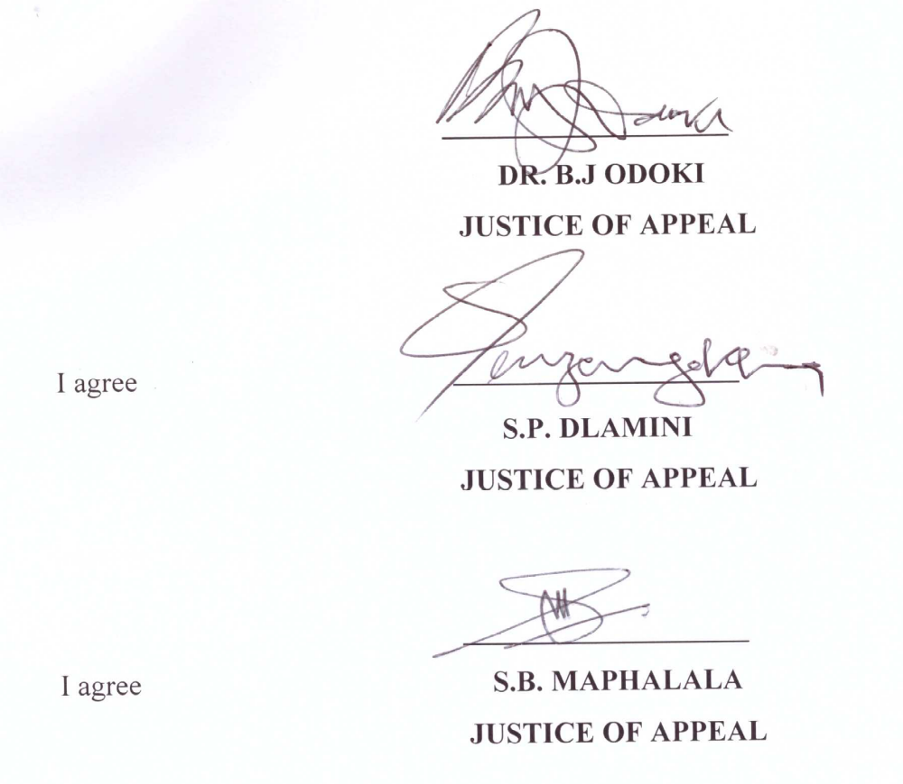

FOR THE APPELLANT: ADVOCATE L.M. MAZIYA
FOR THE RESPONDENT: ADVOCATE D.A. SMITH SC

