

IN THE SUPREME COURT OF SWAZILAND

JUDGMENT

Case No. 02/2017

In the matter between:

TONY ZOLA MAMBA Appellant
and

REX Respondent

Neutral citation: Tony Zola Mamba V. Rex (02/2017) [2018] SZSC 12

(9th May 2018)

Coram: Dr. B.J. Odoki JA, S.P Dlamini JA and J.P Annandale JA

Heard : 8 March 2018
Delivered : 9 May 2018

Summary: Murder – Appeal against conviction of murder with extenuating circumstances – Provocation – Principles involved – Provocation not canvassed in the Court a quo – the requirements for provocation not supported by the evidence – Appeal dismissed and the conviction of murder and sentence of twenty years imprisonment confirmed.

JUDGMENT
S.P DLAMINI JA

BACKGROUND AND FACTS
[1] The Appellant in this matter was convicted by the High Court for the murder of Kaylor Glover (“the deceased”).

[2] The Appellant was indicted at the High Court for murder in that on or about the 15th March 2015 and at or near Nhlangano area, he did unlawfully and intentionally kill the deceased by striking her twice on the head with an axe.

[3] The High Court found the Appellant guilty of murder with extenuating circumstances as per the judgment of His Lordship M.C.B Maphalala (the Chief Justice) delivered on 14 October 2016. The Appellant was then sentenced to twenty years which was backdated to commence on 16th September 2015 in consonance with Section 145 of the Criminal Procedure and Evidence Act No. 67 of 1938.

[4] On 9 February 2017 the Appellant lodged an appeal against the judgment of the High Court against both conviction and sentence. None of the grounds of appeal initially relied upon alleged any provocation. However, the Appellant subsequently filed amended grounds of appeal in which provocation was introduced as an additional ground of appeal, pursuant to an Order of this Court granting him leave to amend the grounds of appeal.
[5] At the hearing of the appeal, Counsel for the Appellant limited the appeal to the ground of provocation and did not pursue any of the other grounds as contained in the amended notice of appeal. Counsel for Appellant submitted that the Court a quo ought not to have convicted the Appellant of murder in view of the alleged provocation. He implored the Court to accept that the evidence before the Court a quo showed that there was provocation against the Appellant and accordingly this Court should return a verdict against him of culpable homicide and reduce his sentence accordingly.

[6] The relevant facts and evidence falling for consideration before this Court as per the trial in the High Court is set out in the ensuing paragraphs herein.

[7] Two groups were involved in the events resulting in the death of the deceased. On the one side there was the group on the side of the deceased and on the other there was the group on the side of the Appellant.

[8] Some of the people in either side of the two groups had some form of standing dispute among them. On the fateful day which resulted in the loss of life of a defenceless woman (the deceased), the two groups met each other at various stages of the day.

[9] One of such meetings took place at Club Rehab in Nhlangano. The Appellant came into the Club and found the deceased together with her friend (PW2) and upon seeing them he directed a blatant sexually charged statement against the deceased. The deceased, not without justification, took exception to such a statement and in a well-known two-letter phrase told the Appellant to get lost and she did nothing further. The Appellant then shoved and assaulted the deceased. Her friend (PW2) was apparently more infuriated with the behaviour of the Appellant and she physically attacked him.

[10] A skirmish ensued with initially involved the Appellant, the deceased and PW2. Later, it expanded to involve both groups. This initial skirmish at some stage ended, albeit only temporarily. The groups proceeded to where their respective cars were parked outside the Club and minded their different business.

[11] While the respective groups seemingly cooling off, the Appellant took an axe out of a car and confronted the deceased’s group. The people on the side of the deceased were able to run away from the imminent attack by the Appellant However, the deceased was not so fortunate. The Appellant fatally assaulted her by hitting her twice on the head with an axe. When the deceased was hit for the first time, she collapsed and fell on the ground. While she was lying unconscious, the Appellant again struck her on the head, with his lethal weapon. The Appellant further kicked the deceased all over the body while she was lying unconscious, mortally wounded.

[12] Thereafter, the two groups were able to come to their senses and the deceased was rushed to the Nhlangano Health Centre. Again, at the Health Centre when the two groups met again, the Appellant once more took out the axe and chased after the deceased’s group but they were all able to escape and the skirmish ended there.
[13] The deceased was to later die of the injuries inflicted on her by the Appellant and the Appellant was charged with the murder of the deceased. The Appellant was tried before the Court a quo and was convicted of the murder of the deceased, coupled with a finding of extenuating circumstances. He was sentenced to twenty years imprisonment, appropriately backdated.

THE APPLICABLE LAW
[14] As already stated above, the Appellant’s appeal is premised on application of the doctrine of provocation. In our jurisdiction the defence of provocation calls for the consideration and application of the Homicide Act No. 44 of 1959 (“the Act”).

[15] The purpose of this Act is to amend the common law relating to the crime of homicide. Section 2 of the Act provides;
“2. (1) A person who:-
- Unlawfully kills another under circumstances which but for this section would constitute murder; and
- Does the act which causes death in the heat of passion caused by sudden provocation as defined in Section 3 and before there is time for his passion to cool;
Shall only be guilty of culpable homicide.
- This section shall not apply unless the Court is satisfied that the act which causes death bears a reasonable relationship to the provocation (emphasis added).
[16] In Section 3, the Act defines provocation as follows;
“3. (1) Subject to this section “provocation” means and includes any wrongful act or insult of such nature as to be likely, when done or offered to an ordinary person or in the presence of an ordinary person to another who is under his immediate care or to whom he stands in a conjugal, parental, filial or fraternal relation or in the relation of master or servant, to deprive him of the power of self-control and to induce him to assault the person by whom such act or insult is done or offered.
(2) In this section “an ordinary person” means an ordinary person of the class of the community to which the accused person belongs…”

ANALYSIS AND APPLICATION OF THE LAW.

[17] The appeal stands or falls on whether the Appellant was provoked justifying the killing of the deceased. The defence of provocation is fairly common in our jurisdiction and our Courts have consistency pronounced themselves on it.

[18] In the matter of William Valindzawo Ndlandla Vs. Rex Criminal Appeal No. 19/2015 the Court inter alia dealt with the defence of provocation vis-a-vis the Homicide Act of 1939 and the distinction between the crimes of murder and culpable homicide (See also Annah Lokudzinga Mathenjwa Vs. Rex 1976 SLR 25, R Vs. Paulus Nkambule 1989-1995 (1) SLR 405 and R Vs Aaron Fanyana Dlamini, 1979-1981 SLR 30).

[19] In that matter, in a unanimous judgment, this Court formulated the test as whether the defence of provocation may succeed or not and stated in paragraph (36) at page 21 that:
“That key phrase lies in the underlined words: “which but for”. A person who otherwise would be convicted of murder, were it not for the saving grace of the statute AND who kills in the heat of passion caused by sudden provocation before there is time for his passion to cool may avoid a conviction of murder. Most importantly, the Court must be satisfied that the act which causes death bears a reasonable relationship to the provocation. Also, that the act of provocation on which reliance is placed, must deprive the accused of the power of self-control and to induce him to assault the other.”

[20] In this matter, the Appellant’s entire basis’ for the defence of provocation is the two letter phrase directed to him by the deceased when she was with her friends in the pub, prior to the altercation. This was an immediate spontaneous response to a demeaning remark, loaded with sexual innuendo, which the Appellant directed towards the deceased, in full earshot of her companions.

[21] However, the evidence presented a different story from his interpretation as to how his intense provocation arose. The Appellant was the initial instigator. He is the one who upon entering the pub directed a sexually highly charged statement towards the deceased who responded with the two-phrase statement telling the Appellant to get lost. In the circumstances, it was actually the Appellant who provoked the deceased.
[22] There is no evidence that the deceased did anything against the Appellant immediately after the verbal exchanges. However, it was the deceased’s friend (PW2) who was aggrieved by the Appellant’s statement and who physically retaliated against the Appellant.

[23] Further, the evidence shows that there is a period where the fight had stopped and the two groups were minding their own business when the Appellant, without any explanation, sprang to action. He took an axe out of a car and fatally assaulted the deceased.

[24] Therefore, it cannot be said that in this matter, the act that caused the death of the deceased bore “a reasonable relationship” to the alleged provocation and that the accused was deprived of his “power of self-control”, such that it induced him to assault the deceased (See the formulation of the test in paragraph [19] above as per the William Valindzawo case).

[25] The Appellant’s contention is that the Court a quo merely concluded that there was no provocation against the Appellant without a proper evaluation of the evidence which he argues to have established the defence of provocation in his favour.

[26] In the judgment of the Court a quo, His Lordship the Chief Justice at paragraph [109] and [110] at pages 48 to 49 stated that;
[109] “There is no evidence before Court that the accused acted in self-defence. Furthermore, there is no evidence that the accused was provoked by the deceased or the people who were with the deceased. On the contrary the evidence shows that it is the accused who provoked the deceased, PW2 and Ryan leading to the fight between them. The evidence shows that the accused was in fact the aggressor. Similarly, there is no evidence that the accused committed the crime due to intoxication.

[110] The Crown witnesses proved to be honest and reliable when giving their evidence; they further corroborated each other. The evidence of the Crown witnesses was credible. On the other hand the accused’s evidence was not corroborated by any other evidence. The accused failed to lead the evidence of his friends Sicelo and Sidumo who were with him during the commission of the offence to support his evidence. He alleged that he was attacked by a mob who assaulted him until he was unconscious, and, that a woman called Nomcebo assisted him to rise up and walk to his motor vehicle, however, he failed to lead the evidence of Nomcebo to prove this allegation.”

[27] At least in relation to the deceased, it cannot be remotely substantiated that the Appellant was acting in self-defence or that he assaulted her in the heat of passion due to any conduct on her part. The contention on behalf of the Appellant that he was acting in self-defence is preposterous in the circumstances of this case. There cannot be any explanation how he was acting in self-defence against a non-conscious body of a woman that he had just bludgeoned to the ground with an axe. This ground of appeal, the only one to be advanced in appeal, therefore stands to be rejected.

[28] Regarding the appeal on sentence, it is demonstrable on the evidence before this Court that the Court properly considered the triad of factors namely a balance between the interests of Justice, society and the accused person. The sentence of 20 years for the conviction of murder, with extenuating circumstances, is on all fours within the established guidelines and it is in line with the range of sentencing in such cases which is now firmly established in our jurisdiction. In my view the sentence of the Appellant by the Court a quo was rather on the lenient side. This Court is painfully aware of the fact that the incidence of violent crimes especially violence against women and children has reached alarming proportions. Therefore, our Courts are under a legal duty to pass deterrent sentences even within the context of the well-established triad approach to sentencing.

[29] Furthermore, the Appellant’s appeal regarding the sentence was largely premised on altering the conviction of murder to culpable homicide. However, he was unsuccessful to prove any lawful basis to so alter the judgment of the Court a quo. Similarly, the appeal on sentence must fail.

CONCLUSION
Therefore, the Court rejects that the Appellant has proved any provocation against him, and that he acted in self-defence and consequently agrees with the conclusions of the Court a quo.
In view of what is already stated above, the Court declines to interfere with the judgment of the Court a quo on conviction and sentence as there is no lawful basis to do so. The appeal on sentence was to be relevant only if the appeal was successful on conviction. The appeal is dismissed and the appeal against sentence does not warrant any further consideration.

COURT ORDER
Accordingly, the Court makes the following Order that;
- The appeal be and is hereby dismissed; and
- The judgment of the Court a quo, a conviction of murder and sentence of 20 (twenty) years imprisonment is hereby confirmed.
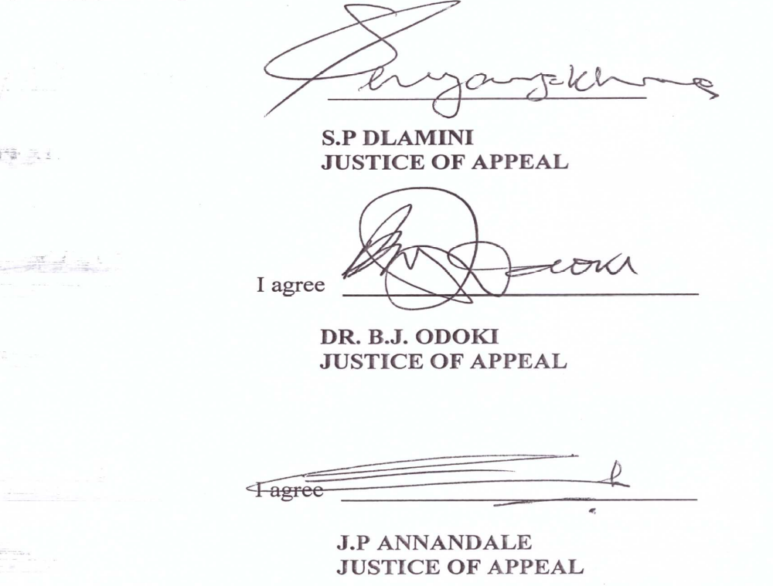

For the Appellant : Mr. B.J Simelane (Ben J. Simelane & Associates)
For the Respondent: Mr. T. Dlamini (DPP’s Office)

