
IN THE SUPREME COURT OF ESWATINI
JUDGMENT
HELD AT MBABANE APPEAL CASE NO.07/2018

In the matter between:
ALPHEOUS NXUMALO APPELLANT
and
SWAZI OBSERVER (PTY) Ltd RESPONDENT
t/a OBSERVER ON SATURDAY

Neutral Citation: Alpheous Nxumalo vs. The Swazi Observer (PTY) Ltd t/a Observer on Saturday (07/2018) [2018] SZSC 27 (18 October 2018)

Coram: DR. B.J. ODOKI, JA
S.P. DLAMINI, JA
J.P. ANNANDALE, JA

Date heard: 13 August 2018
Date delivered: 18 October 2018

Summary: Civil Law - Defamation – Respondent newspaper publishes article alleging that the Appellant declared that he is HIV Positive – Publication based on Appellant’s testimony in church on public Television Channel - The Last Hour - Miracle TV – whether publication defamatory of the Appellant – whether article was false, negligently, maliciously published or was unlawful – whether publication of the article was reasonable – whether the publication was in public interest – whether article violated the Appellants right to privacy – whether the publication was protected by the right to freedom of the press – whether the Appellant suffered any damage.

JUDGMENT

DR. B.J. ODOKI J.
[1] This is an appeal from the judgment of the High Court whereby the court a quo dismissed with costs the Appellant’s action for defamation against the Respondent.
[2] The brief facts of the case as accepted by the trial judge were that the Appellant appeared in a South African Television Broadcast on a network which covers Christian Evangelical content known as Television Gospel Channel or the Last Hour Miracle Television. The substance of the broadcast was that the Appellant had attended a church service where he requested in front of parishioners that the Pastor prays for him and his family.

[3] During the said prayer the Appellant in his testimony and the Pastor in response both uttered the following words which were captured in the video recording later viewed by the court a quo;
“ Mr. Nxumalo: I have lived with my wife, we have been married for 24 years. I know that some people will say this should not be said in a live broadcast. But what if I keep quiet and somebody is going through the same experience? I have lived with my wife with an HIV status and we agreed with her, a long time ago that I will share it so that other people can get strength off, of it.
So, 14 years of that 24 years I have lived with her in that condition and I didn’t believe that God will reveal that to you…….
Priest: Imagine God revealed to me about her blood….
Mr. Nxumalo: Oh, Jesus
Priest: I imagine God revealed to me about her blood
(INAUDIBLE) about her blood…..

Mr. Nxumalo: Oh, my God……

Priest: Let me send an angel……

Mr. Nxumalo: Thank you Jesus…..

PRIEST PROCEEDS TO DO WHAT SEEMS LIKE CASTING OUT SPELLS…..

Priest: Your (INAUDIBLE), be free, be healed and be saved. Thou says the Lord of Host

Mr. Nxumalo: Thank you Jesus, I receive

Priest: It is done, clap hands for Jesus …….”

[4] The Respondent having obtained the video clip of the televised broadcast went ahead and published an article in its newspaper in which the Respondent claimed that was a narrative of what the Appellant had said in the televised broadcast. Before publication of the article, the Respondent sought to confirm whether the gist of the publication was correct, but the Appellant declined to be interviewed claiming that sickness was a matter of a private nature.

[5] The article published in the Respondent’s Saturday Observer was to this effect.

“EX MD ALPHEOUS NXUMALO IS H.I.V. POSITIVE Page 3”
On page 3 of the publication appeared the following sub-heading;
‘Ex – MD Alpheous Nxumalo declares; I am H.I.V. positive”

The narrative then proceeds to read as follows:
“Former Swazi Observer Managing Director (MD) Reverend Alpheous Nxumalo is HIV positive. He has been living with the condition for the past 14 years. He made this touching but educative confession to a South African Miracle Pastor that later took time to pray for him during a church service in that country recently.

This confession was then broadcast on one of Southern Africa’s most followed gospel channels, the Last Hour Miracle TV, where Nxumalo explained his situation to the pastor and his congregation on why he had decided to pour his heart out on his HIV status. The strength by the Observer on Saturday of publishing this revelation is obtained from the reverend’s own confession in the church that they discussed the matter with his wife a long time ago and agreed to share it with other people so that they can get strength from it. Speaking during the service, Nxumalo revealed that he has lived with his wife and that they have been married for the past 24 years. He then broke the news of his status by stating that he was alive to the fact that some people feel that he should not be disclosing such news in a live broadcast. “But what if I keep quiet when somebody is going through the same experience? I have lived with my wife with an H.I.V positive status for 14 years of the 24 that we have been married. We agreed with her a long time ago that I would share it so that others can get strength from it. I didn’t believe that God would reveal that to you” he said before screaming OH! My God, upon where the pastor then started praying for him.

“Let me send an angel to you. You will be free, be healed and be saved, thus says the Lord.” Prayed the pastor.

Within a moment, the pastor then stated that, “It’s done” before Nxumalo was heard shouting “I receive it” before he then gave a moving sermon of his own as the congregants listened attentively.

[6] In his claim, the Appellant stated that the Respondent published a highly defamatory and grossly malicious article and the words published were per se false, wrongful and defamatory of the Appellant.

[7] In their plea, the Respondents raised the following defences, among others:-

- That the article was substantially accurate of the Appellants testimony in a leading public television channel – The Last Hour – Miracle Television.

- That the Respondents were not aware of the falsity of any averment in the article.

- That the article was published in public interest to discharge their duty to inform the public about newsworthy events and matters of public interest.

- That the Respondents were not negligent in publishing the article.

- That the Respondents did not publish the articled recklessly i.e. not caring whether their contents were true or false.

- That the article was published without intention to injure the Appellant.

- That the publication was objectively reasonable.

- That the Respondents deny that the article was defamatory of the Appellant and that he suffered any damages.

- That the Respondents deny that the publication was an invasion of the Appellant’s privacy.

[8] After hearing oral evidence and submissions of counsel, the judge in the court a quo held that the Respondents were not negligent or unreasonable in publishing the article that the Appellant was HIV positive. Accordingly, the learned judge dismissed the Appellant’s action with costs.

[9] Being dissatisfied with the above judgment, the Appellant noted an appeal to this Court based on the following grounds:

- “The court a quo erred in fact and in law in failing to find that the article grounding the plaintiff’s causa was indeed defamatory of plaintiff;

- The court a quo erred in law and in fact in finding that plaintiff’s words in the video clip and / or recording as broadcasted amounted to an admission by plaintiff to being personally HIV positive;

- The court a quo erred in fact and in law in failing to find that the publication, of the article giving rise to the causa, was untrue and / or negligent and unreasonable and at complete variance with the Respondents code of ethics;

- The court a quo erred in fact and in law in dismissing the plaintiffs claim and with costs. The court a quo’s exercise of discretion on the question of costs, was, as demonstrated in the preceding grounds of appeal above, based, with respect, upon a wrong principle, of fact and of law”

[10] Arguing the first ground of appeal, the Appellant submitted that the statements contained in the article concerned were published about him and concerned him, and as such they were per se false, wrongful and defamatory of him. The Appellant enumerated how the statements were defamatory of him in the following ways:

“ 8.1 They were more than reasonably capable of conveying to the reasonable reader and / or alternatively they expressly conveyed to the reader that the defamatory and malicious article referred to him; and

8.1.1. The words used were in their very nature meant to convey a maliciously and injurious falsehood and to convey a defamatory meaning to the readers of the said publication by imputing upon the plaintiff infliction with a highly sexually contagious and/or venereal Virus and by extension an imputation of low moral character by plaintiff most importantly by failing to make such confession earlier to either his fellow congregants or family members and keeping such secret for the last 14 years;

8.1.2 The article and words were used to convey the message that plaintiff could morally not be trusted though being a Christian Evangelist and was inflicted with Sexually transmitted viruses.

8.1.3 The words used were in their very nature meant to convey a malicious and injurious falsehood and to convey a defamatory meaning to the readers of the said publication, viz that plaintiff was HIV Positive and had been in such condition for the past 14 years;

8.1.4 The said article was published with the intention to defame plaintiff, to injure his reputation as a Christian Evangelist and Man of God, businessman, professional writer and political analyst.”

[11] In his heads of argument The Appellant states that he gave evidence that pursuant to defamatory article he suffered damages in that,

“ 9.1 The resultant public reaction caused members of the public to believe that he was HIV Positive and / or inflicted with a highly sexually transmitted and / or sexually contagious virus;

9.2 It lowered him in the estimation of the public as it unequivocally described and categorized plaintiff as being chronically ill and infected with a chronic illness that has (is) [unfortunately been socially stigmatized and associated with sexual promiscuity, infidelity and a failure to practice safe sex and the victims to which are associated with shame and stigma and are marginalized by society as a result;

9.3 As a Christian Evangelist and Preacher, the article has therefore further aroused Ridicule, obloquy, contempt, and has caused Plaintiff to be shunned , pitied and avoided. The article further imputed very low moral character upon the plaintiff;

9.4 The article has also reflected upon the plaintiff’s capacity as a Christian Evangelist, Business and Political Analyst and Writer and has diminished the willingness of others to associate with him. The article has therefore been calculated to expose the plaintiff to hatred, undue ridiculed contempt and pity.

9.5 The article has further been traumatic to plaintiff’s family and children and they have endued ridicule, stress and pain as a result of the same;

9.6 It resulted in subsequent rumors which had a negative impact on plaintiff’s good reputation as a Christian Evangelist, a businessman, professional writer and political analyst;

9.7 The article further caused plaintiff not only to suffer damage to his reputation, but also suffer damage to any prospects he may have had in the professional world in general.”

[12] In his judgment the judge in the Court a quo that addressed himself to the issue whether the statement published in the impugned article were defamatory as follows:

“ [10] Notwithstanding, I have, no doubt that what this Court has been
burdened and lacked with is the question of whether or not in terms of the law as pronounced herein, the Plaintiff was defamed or not.”

[13] The learned judge then referred to principles of common law as exposed by Prof. Jonathan M. Berrcheel in his book The Law of Defamation in South Africa, Juta 1985 p. 150, and in his treatise on Personality Rights and Freedom of Expression, Juta 1998 where he states that there are two requirements which the plaintiff must meet in order to succeed in an action for defamation namely:

- An inference of unlawfulness or wrongfulness, and

- An inference of animus injuriandi (subjective intention) on the part
of the individual defendant to impair the plaintiff’s reputation with
knowledge of unlawfulness.

[14] The learned judge also referred to the case of National Media Ltd v Bogoshe 1998 (4) SA 1195 where it was held that the members of the media are not entitled to rely on absence of subjective animus injuriandi as a defence because their liability is based on an objectively assessed criterion of the reasonableness of the publication – a criterion that would include an investigation into whether reasonable steps were taken to verify the accuracy of the information before publication – as to whether negligence was present or not. The Court a quo also observed, that the criterion of strict liability was rejected in the case of Bogoshi case (supra) and the test of reasonableness was adopted.

[15] However, instead of answering the question whether the statements in the impugned article were indeed defamatory of the Appellant, the Court a quo went ahead to consider whether the Respondents were negligent and consequently unreasonable in publishing the story. The Court came to the conclusion that on the evidence before it, it could not infer any negligence or unreasonableness in the actions of the Respondents.

[16] In my view, the Court a quo erred in not specifically addressing the question whether the statements published by the Respondents were defamatory of the Appellant. Had the Court a quo done so, it would have come to the finding that the statements published by the Respondents were defamatory per se of the Appellants, as they tended the lower the reputation of the Appellant in the opinion of right minded people, and were also untrue.

[17] In the second ground, the Appellant complains that the Court a quo erred in finding that the Appellant’s words in the video clip as broadcasted amounted to an admission by the Appellant of being personally HIV positive.

[18] In his judgment, the learned judge, in the Court a quo dealt with this issue as follows;

“[17] This brings us to the question of whether the Defendants were negligent and consequently acted unreasonably in publishing the story. We have seen that the facts point out to the fact that the Plaintiff did publicly state that his wife and him had been living with the HIV virus for the last 14 years. Looking at the statement he made in the live broadcast in isolation to the events that occurred prior to the publication would be erroneous in ascertaining whether the Defendants acted reasonably or not. The truth as per the evidence of both the Plaintiff and the 3rd Defendant was that there was a telephonic discussion between the two that took place the day prior to the publication as I have outlined above. The Plaintiff, it is clear, was not forthcoming on the matter of whether he is in fact H.I.V positive or not. The only inference that can be drawn from his reaction to 3rd Defendants phone call was that he was surely given a chance to set the record straight, i.e. that he is in fact not HIV positive. That he is not HIV positive is a fact he had medically ascertained well prior to the life television broadcast and the subsequent publication by the Defendants. The life broadcast was a public forum.

[18] Given the law and the evidence before me I cannot infer any negligence or unreasonableness in the actions of the Defendants in publishing the article that in fact Plaintiff is HIV positive. When any reasonable person hears the Plaintiffs’ words in the live broadcast I cannot see any negation of the inference that can be adduced, i.e, that, in fact, the Plaintiff was saying that his wife and him are HIV positive must as I loathe such a conclusion. The ratio is definitely tipped in favor of the Defendants when you take into consideration that the Plaintiff is a public figure, vis, he is a pastor and a political publicist of reknown.

In his evidence the Plaintiff acknowledged that he is a public figure thus confirming his assertion at paragraph 6.1.4 of his Particulars of Claim. It is trite that public figures are quite susceptible to tilting the scales in favor of the defence. See Holomisa v. Argus Newspapers Ltd 1996 (2) SA 588 (W)”

[19] The Appellant submitted that the statements in the article describing him as
being HIV positive were untrue because it was his wife who was HIV positive
and not himself. It was the contention of the Appellant that the video clip was
to refer to him instead of his wife.

[20] The Respondents have argued that the Appellant did not single out his wife as being the one who is HIV positive neither did he say that he himself was not HIV positive. The Respondents maintain that the Appellants expressly stated that he had lived with his wife, with an HIV status for 14 years. According to the Respondents, the interpretation the Appellant sought to give to his statement is subjective and not objective as the rest of defamation requires. The Respondents further argue that the Appellant was given an opportunity to comment on the matter but he refused to do so.

[21] It appears to me that both the Respondents and the Court a quo misinterpreted or misapprehended the statements made by the Appellant during the live broadcast or video clip. The Respondents singled out the Appellant as the one who was HIV positive. They claimed that he had confessed to the Pastor or before the congregation regarding his HIV status. The Court a quo took the view that the Appellant admitted or declared that he and his wife were HIV positive.

[22] Unfortunately , none of this interpretations tally with ordinary meaning the statement of the Appellant in the live broadcast when seriously scrutinized looking at the broadcast as a whole. It is pertinent in this connection to have regard to the responses of the pastor who clearly understood that the Appellant was referring to his wife and stated “Imagine God revealed to me about his blood….”

The Appellant also kept referring to his wife, “So 14 years of that 24 years I have lived with her in that condition and I didn’t believe that God will reveal that to you….” What would be the point of referring to his wife, if the Appellant’s intention was to declare his own HIV status to the congregation or the pastor? Moreover, according to his uncontroverted evidence, the Appellant is not HIV positive.

[23] It was argued for the Respondents that they were justified in publishing the article because the Appellant refused to comment on his HIV status. I rather think that the Appellant gave a sound reason namely that matters relating to sickness are private matters not for public consumption. Therefore, I do not take this excuse as a valid reason for publishing an untrue and defamatory story about the Appellant. The Court a quo therefore erred in holding that the only inference to be drawn from the Appellant’s refusal to set the record straight was that he was HIV positive.

[24] In the third ground of appeal, the complaint is that the Court a quo erred in fact and in law in failing to find that the publication of the article giving raise to the cause was untrue and or negligent and unreasonable and at complete variance with the Respondent’s own code of ethics. I have already addressed the issue whether the publication was untrue and come to the conclusion that the Appellant did not confess that he was HIV positive, and that the publication was false and defamatory.

[25] However, I must consider whether the Court a quo erred in finding that the Respondents were not negligent and unreasonable in publishing the article. The test of reasonableness was laid down in the case of National Media Ltd v Bogoshi (supra) where the Supreme Court of Appeal of South Africa, stated,

“ 3.5.1 In my judgment we must adopt this approach by stating that the publication in the press of false defamatory allegations of fact will not be regarded as unlawful if upon a consideration of all the circumstances of the case it is found to have been reasonable to publish the particular facts in the particular way at the particular time…..
In considering the reasonableness of the publication account must obviously be taken of the nature extent and tone of the allegation ….What will also figure prominently is the nature of the information on which the allegations are based and the reliability of their source as well as the steps taken to verify the information”

[26] The Respondents argued that the Court a quo correctly applied the test for defamation against the mass media as demonstrated in said judgment. The Respondents repeated their assertion that the Appellant confessed to being HIV positive before a congregation in a church in South Africa and that in the use of the plain language the Appellant was referring to himself as having lived with HIV with his wife for 14 years.

[27] It was therefore the contention of the Respondents that the newspaper article complained of was a substantially true report of what was stated by the Appellant. The Respondents also submitted that the meaning alluded to by the Appellant was subjective and the Court a quo was justified in holding that the average ordinary person would have interpreted the Appellant’s statement to mean that he and his wife were HIV positive.

[28] The Respondents also argued that it was reasonable to publish the article in the manner they did at the given time and in the prevailing circumstances.
They maintained that the article was not published negligently as they took reasonable steps to get a comment from the Appellant before publishing the story, and the Appellant never denied the truthfulness of the publication, other than saying that it was his own private matter.

[29] I have already stated in this judgment that a careful reading of the live broadcast or video clip as a whole does not support the Respondents’ claim that the Appellant was referring to himself and not to his wife. The pastor who was present in the congregation readily understood the Appellant to be referring to his wife, and any reasonable person would have understood the statement to mean so. The argument by the Respondents that the article was substantially true cannot be correct given he heading that “EX MD ALPHEOUS NXUMALO IS HIV POSITIVE” and sub-heading that “Ex – MD Alpheous Nxumalo declares: I am HIV positive.”

[30] It was also submitted by the Respondents that the publication was reasonable because they took steps to verify the correctness of the statement in the video clip from the Appellant who did not deny the statement that he was HIV positive. In my view the response given by the Appellant that matters relating to sickness are private and not for public consumption was reasonable. The Respondent should have taken more caution in publishing the statement since it was highly sensitive and private.

[31] The Appellant contended that the publication breached the Swaziland Journalists Code of Ethics, particularly article 19 which stipulates in part as follows;

“19. It is recognized that the actions of the media have real consequences on the people’s lives. This is more so in the area of reporting on HIV and AIDS where harmful reporting may result in negative implications for the people concerned and promote stigma and discrimination. Reporting HIV and AIDS is a special area that requires separate guidelines for reporting on the epidemic. This guide aims at implementing the Swaziland National Association of Journalists Code of Ethics as well as in-house codes and provides a standard of reporting HIV and AIDS.”

[32] The said Code of Ethics in Article 19.2 recognizes the right to privacy and confidentiality, and emphasises that in the context of reporting on HIV and AIDS, the HIV status of an individual is private unless indicated otherwise. In Article 19.3, the Code states that the name or photograph of an individual with HIV should not be published without the person’s consent.

[33] In considering the test of reasonableness or unreasonableness of the publication, it is also necessary to take into account the professional ethics governing the publication of such statements as there is a need to balance the media’s rights to inform the public on matters of public interest and the need to protect the individual’s right to dignity and privacy. In this case the Respondents failed to strike the right balance by publishing the article.

[34] The last ground of appeal is that the Court a quo erred in dismissing the Appellant’s claim with costs. For the reasons I have already given above, this ground must succeed with the result that the appeal must be allowed.

[35] As the Court a quo did not assess the quantum of damages, this Court is not in a position to consider the issue which the Appellant could not address in his heads of arguments. Accordingly, the case must be remitted to the Court a quo to assess the quantum of damages

[36] For the foregoing reason, I make the following order;

- The Appeal is allowed.

- The decision of Court a quo is set aside and substituted with an order that the Plaintiff’s claim succeeds.

- The case is remitted back to the Court a quo to hear and determine the quantum of damages to be awarded to the Appellant.

- The Appellant is awarded costs.

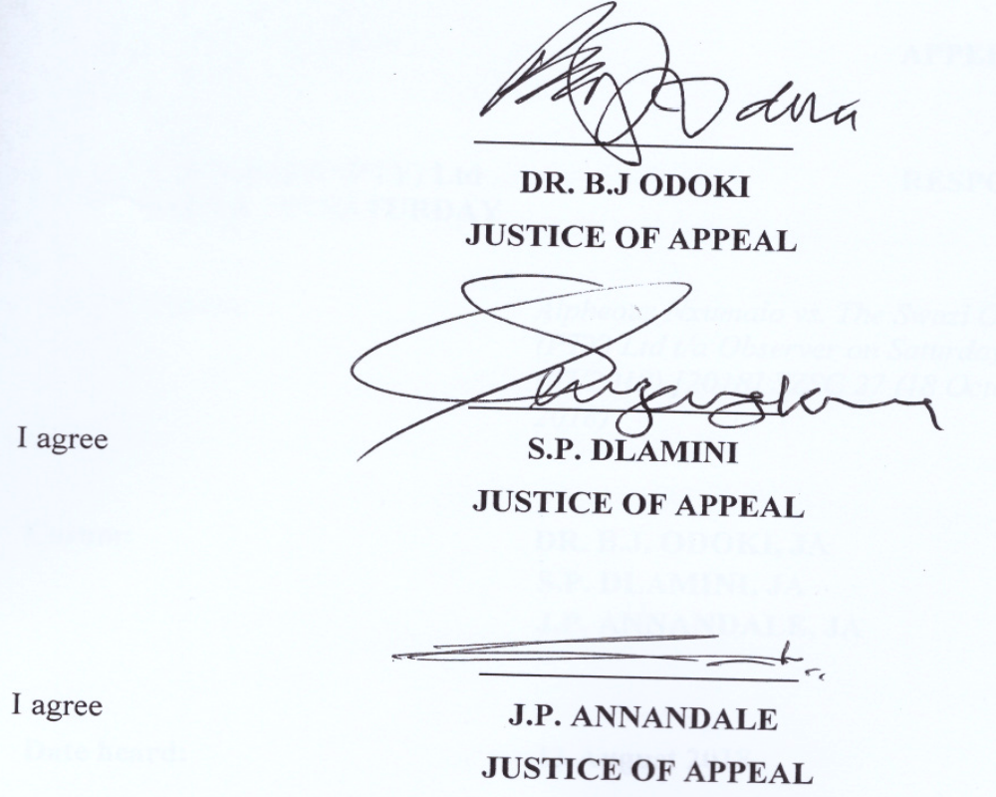

For the Appellant: Advocate Simelane
Mr. N. Ndlovu
For the Respondents: Z. Shabangu

