

IN THE SUPREME COURT OF SWAZILAND

JUDGMENT

Civil Appeal Case No: 94/2016

In the matter between:

SIKELELA MAGAGULA APPELLANT
And

THE ATTORNEY GENERAL RESPONDENT

Neutral citation: Sikelela Magagula v The Attorney General (94/2016) [2018] SZHC 3 (2018)

Coram: M. C. B. MAPHALALA, CJ
B. J. ODOKI, JA
S. P. DLAMINI, JA

Heard : 15 MARCH, 2018

Delivered : 12 APRIL, 2018

SUMMARY

Civil Appeal – delictual claim for damages arising from unlawful arrest, detention and torture – liability denied on the basis that the arrest and detention was lawful and based on reasonable suspicion that an offence was being committed – respondent further denied that appellant was tortured and that the period of detention was unreasonable;

Court a quo held that the arrest and detention was justified in law as it was based on reasonable suspicion that an offence was being committed; and, that the appellant was released within a reasonable time;

Court a quo further held that the appellant was tortured by the police, and, that they are consequently liable in damages; however, the determination of the quantum of damages in respect of torture was postponed sine die;

On appeal held that the Constitution allows a detention of forty-eight hours in respect of a person who was arrested without a warrant in circumstances in which there is reasonable suspicion that he has committed an offence under any law governing the possession or disposal of arms and ammunition;

Held further that the appellant was detained in excess of four hours from the maximum of forty-eight hours allowed by law, and, that this constitutes a violation of his right to personal liberty;

Held further that the court a quo was correct in finding that the appellant was tortured, and that such torture is an infringement of the appellant’s right to dignity.

Accordingly, the appeal is upheld with costs, and, the matter remitted to the court a quo for a determination of quantum of damages for torture and unlawful detention.

JUDGMENT

JUSTICE M. C. B. MAPHALALA, CJ:

[1] The appellant, a former Police Officer, was arrested by the police on the 7th November, 2013 at his homestead at about 6 am. The arrest was made in the presence of his family and members of the community. It is apparent from the evidence that the arrest was intended to conduct investigations. The appellant was suspected to be in possession of explosives; however, upon a search on his premises, no explosives were found in his possession, and, he was subsequently released on the 9th November, 2013 at about 10 am. In his amended particulars of claim, the appellant sought damages in the sum of E380, 000.00 (Three Hundred and Eighty Thousand Emalangeni) in respect of unlawful arrest and detention, contumelia, loss of business, pain and suffering, medical expenses as well as legal costs.

[2] It is apparent from the evidence that upon his arrest, the police conducted a search on his premises looking for explosives that were alleged to be in his possession but none were found. A second search was made by the police at his homestead on the morning of the 9th November, 2013 using sniffer dogs, bomb disposal experts and the counter-terrorism unit; the appellant was present. Again no explosives were found. The appellant was subsequently released at 10 am on the same day for lack of evidence to prosecute.
[3] The respondent denies that the arrest and detention were unlawful on the basis that there was a reasonable suspicion that the appellant had committed an offence of possessing explosives. The court a quo did not misdirect itself when making the finding that there was a reasonable suspicion of commission of the offence. The appellant admits that Sonke Dube, a member of the proscribed political organization, PUDEMO, had approached him several times asking him to join the organization. Eventually he had agreed to go with him to meet the leaders of the organization.

[4] The appellant was subsequently taken by Sonke Dube to a homestead at Mhlaleni in Matsapha where PUDEMO was keeping their explosives. At the premises he was shown the weapons and further met other members of the organization. The explosives were intended to be used at KaMkhweli and Macetjeni areas during national elections. The police were able to arrest Themba Dlamini and Big Boy Mnisi after they had been found in possession of the explosives; Themba Dlamini had in turn implicated the appellant that he was also in possession of explosives.
[5] There is evidence that the appellant is a former police officer who was in-charge of an armoury at Ngonini Operational Support Unit (OSSU), and, that part of the weapons under his custody included explosives, and, that he knew how to use them. There is further evidence that the appellant was fired from the police service, and, that he was bitter about his dismissal; this made him a good candidate to disrupt the national elections and bomb the areas of Macetjeni and KaMkhweli. Similarly, there is evidence that PUDEMO was recruiting the appellant partly because of his bitterness at his dismissal and partly because of his knowledge of explosives.

[6] The appellant does not deny that as a former police officer he was obliged to report the commission of the offence to the police; however, he concedes that he did not report the offence to the police. His explanation that he was afraid of members of the organization is not supported by the evidence; and, it was correctly rejected by the court a quo. In addition, the appellant does not explain why he wanted to meet leaders of the organization if he did not want to become a member of the organization. As a former police officer he was aware that PUDEMO is a proscribed organization, and, that possession of explosives is a criminal offence punishable by law.

[7] It is common cause that the appellant was arrested without a warrant. The Criminal Procedure and Evidence Act outlines the circumstances in which the police can effect an arrest without a warrant.

“23. (1) Any peace officer may, without any order or
warrant, arrest any person:

(a) who has in his possession any implement
of house-breaking, and is not able to
account satisfactorily for such
possession;

(b) in whose possession anything is found
which is reasonably suspected to be
stolen property or property dishonestly
obtained, and who is reasonably
suspected of having committed an offence
with respect to such thing;

(c) who obstructs a policeman or other peace
officer while in the execution of his duty,
or who has escaped or attempts to escape
from lawful custody;

(d) who is reasonably suspected of being a
deserter from His Majesty’s naval or
military or air forces or from the Royal
Swaziland Police;

(e) who is or is loitering in any place by
night under such circumstances as to
afford reasonable grounds for believing
that he has committed or is about to
commit an offence;

(f) reasonably suspected of committing or
having committed an offence under any
law governing the making, supplying,
possession or conveyance of intoxicating
liquor or of habit forming drugs or the
possession or disposal of arms and
ammunition;

(g) reasonably suspected of being a
prohibited immigrant for the purpose
of any law regulating entry into or
residence in Swaziland;

(h) found in any gambling house or at any
gambling table, the keeping or visiting
whereof is in contravention of any law for
prevention or suppression of gambling or
games of chance; or,

(i) who is reasonably suspected of being or
having been in unlawful possession of
stock or produce as defined in any law
for preventing the theft of stock or
produce.

(2) If it is provided in any law that the arrest of any
person may be made by a police officer or other
official without warrant, subject to conditions
or to the existence of circumstances set forth in
such law, an arrest by any peace officer,
without any warrant or order, may be made of
such person subject to such conditions or the
existence of such circumstances.

[8] The evidence in the preceding paragraphs shows that the police were justified in arresting the appellant without a warrant on the basis of section 23 (1) (f), that he was reasonably suspected of committing or having committed an offence under any law governing the possession of arms or disposal of arms and ammunition. Counsel for the appellant was correct in his heads of argument:

“3.1 There is no dispute that when the arrest was carried
out on the appellant, the police were acting based on a
reasonable suspicion.

. . . .

3.3 The evidence that was presented to the court a quo
clearly demonstrated that there was a reasonable
suspicion to arrest.

3.4 The appellant did not contest that there may have
been a reasonable suspicion to arrest. He only contests that his detention was unlawful as it was a means of simply conducting an investigation.”

[9] The appellant challenges his detention as being unlawful on the following basis: Firstly, that the detention was for a period of more than forty-eight hours; secondly, that he was never made to appear before Court within the period of forty-eight hours; thirdly, that he was not released from detention before the lapse of forty-eight hours. Fourthly, that the detention was carried out subsequent to an arrest carried out without a warrant of arrest issued by a court.

[10] The Criminal Procedure and Evidence Act as amended provides that a person arrested without a warrant should be released within a reasonable time if he is not charged of a criminal offence.

“30. (1) No person arrested without warrant shall be
detained in custody for a longer period than in
the circumstances of the case is reasonable.

(2) Unless such person is released by reason that no
charge is to be brought against him, he shall, as
soon as possible, and without undue delay, be
brought before a Magistrate’s Court having
jurisdiction upon a charge of an offence.

(3) This section shall not be construed as modifying
the provisions of Part VIII or of any other law,
whereby a person under detention may be
released on bail.

(4) If a person effects an arrest without warrant, he
shall forthwith inform the arrested person of
cause of such arrest.”

[11] The Constitution provides that a person who has been arrested pursuant to a Court Order or upon reasonable suspicion that he has committed an offence or being about to commit an offence should be brought to Court within forty-eight hours - where a person is detained for more than forty-eight hours, the police bears the burden of proving that it was reasonable to keep the person beyond forty-eight hours without releasing him or bringing him before Court.

[12] Section 16 provides, inter alia:

“16. (3) A person who is arrested or detained:

(a) for the purpose of bringing that
person before a court, in execution
of the order of a court; or

(b) upon reasonable suspicion of that
person having committed, or being
about to commit a criminal offence,
shall unless sooner released, be brought without undue delay before a court.

(4) Where a person arrested or detained pursuant
to the provisions of subsection (3), is not
brought before a court within forty-eight hours
of arrest or detention, the burden of proving
that the provisions of subsection (3) have been
complied with shall rest upon any person
alleging that compliance.

. . . .

8. A person who is unlawfully arrested or detained
by any other person shall be entitled to
compensation from that other person or from
any other person or authority on whose behalf
that other person was acting.”

[13] It is not disputed that the appellant was arrested at 0600 hours on the 7th November, 2013 and released on the 9th November, 2013 at 10:00 hours. Accordingly, the appellant was unlawfully detained for four hours. There is no reasonable explanation by the respondent why the appellant was detained in excess of forty-eight hours. Section 16 (4) of the Constitution places the burden upon the respondent to prove that it was reasonable to keep the appellant in detention and not release him or bring him before Court.

[14] It is apparent from the evidence that the appellant was arrested and detained for the purpose of investigation. The police searched the appellant’s homestead on the day of arrest for possible incriminating evidence; however, nothing was found. Later that day the police tortured the appellant, with a view to incriminate himself; the torture continued on the 8th November, 2013 but there was no evidence found linking the appellant to the commission of the offence.

[15] In the morning of the 9th November 2013, the police took the appellant to his homestead to conduct another search pursuant to certain admissions made by the appellant during a torture session. This search yielded no positive results, and, no evidence was found implicating the appellant in the commission of the offence. Notwithstanding the absence of evidence, the police did not release the appellant at his homestead but drove with him back to the police station, a long distance from his homestead. In the circumstances, no reasonable explanation has been advanced by the police why they detained the appellant beyond forty-eight hours as required by the Constitution.

[16] Crown Counsel Sikhumbuzo Hlophe who represented the respondent failed to appear in Court on the 17th August, 2017 when the matter was set down for hearing. The matter was postponed to the 15th March, 2018; however, the respondent’s Counsel did not come to Court. In both occasions no explanation was furnished to this Court for his non-appearance; hence, appellant’s Counsel was allowed to proceed with his submissions in the absence of Counsel for the respondent. The conduct of respondent’s Counsel is reprehensible and disrespectful to this Court.

[17] The respondent is liable to pay the appellant damages in respect of torture and unlawful detention for the four days. This judgment seeks to underline the importance of the Bill of Rights enshrined in the Constitution. It is expressly provided in the Bill of Rights that a person shall not be deprived of personal liberty save as may be authorised by law; hence, a person who has been subjected to unlawful arrest and detention is entitled to be compensated by damages. Similarly, the Constitution frowns upon the torture of suspects to the extent that it provides that the dignity of every person is inviolable; and, it further provides that a person shall not be subjected to torture or to inhuman or degrading treatment or punishment.

[18] Accordingly, the following order is made:

(a) The appeal is upheld

(b) The matter is remitted to the court a quo for a
determination on the quantum of damages
payable to the appellant in respect of torture and
unlawful detention for the four days.

(c) The respondent will pay costs of suit on the ordinary
scale.

For Appellant : Attorney Sipho Gumedze

For Respondent : No appearance

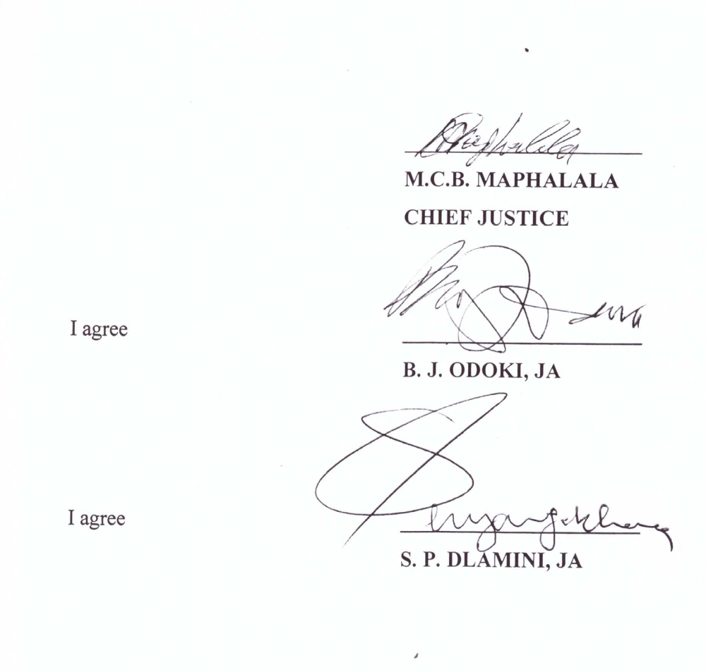

No. 67 of 1938 as amended
Section 23
Paragraph 3.1, 3.3 and 3.4
Section 30 Act No. 67 of 1938 as amended
Sections 16 (3)
Section 16 (4)
Section 16 of the Constitution
Ibid footnote 6
Section 18

