

IN THE SUPREME COURT OF ESWATINI
JUDGMENT
Case No. 30/2017
In the matter between

SENZO MATSENJWA Appellant

And

THE KING Respondent

Neutral Citation : Senzo Matsenjwa and the King (30/2017) [2018]
SZSC 45 (06/11/2018)

Coram : M.C.B. MAPHALALA CJ, S. P. DLAMINI JA and
M. J. DLAMINI JA

Heard : 17th July 2018
Delivered : 6th November 2018

SUMMARY: Criminal Appeal:-Bail Law - Appellant charged with various offences in terms of the Prevention of Corruption Act 3 of 2006 and in the alternative Appellant charged with defeating the ends of Justice and contempt of court - all arising out of alleged breach of his bail conditions attached to his release on bail in a related matter – The Appellant’s previous bail not revoked and denied bail by the High Court in view of the alleged breach - Held that Court a quo erred by not determining whether the proper procedure was to revoke Appellant’s bail – Held that while the Crown was at liberty to seek leave to amend or prefer further charges against the Appellant, it was improper at law not to make a determination as to whether the Appellant breached the bail conditions or not on proper evidence – Held that the Respondent carried the burden of proof that the Appellant committed the alleged breach of his bail conditions and that he was not entitled to be released on bail - Held that the Appeal be upheld and that the judgment of the Court a quo be set aside – Held that the Appellant be and is hereby released on bail under the same bail conditions as obtained under High Court Case No. 496/2015.

ISSUE
[1] This is an Appeal against the judgment of the High Court denying Appellant bail which was delivered on 12th December 2017 by His Lordship Justice Maphanga.

BACKGROUND AND FACTS
[2] The Appellant was previously admitted to bail under High Court Case No. 496/2018 for offences falling under the Prevention of Corruption Act. At the hearing of the matter before this Court, it transpired that the trial was proceeding before the High Court.

[3] After being admitted to bail by the High Court, the Appellant was subsequently re-arrested in September 2017. He was then charged with offences allegedly emanating from an alleged breach of the bail conditions in connection with the matter that is continuing before the High Court.

[4] The Appellant applied before the High Court to be admitted to bail regarding his re-arrest and the subsequent charges preferred by the Crown against him.

[5] The High Court dismissed his application to be admitted to bail. His Lordship Justice Maphanga in paragraph [43] of the Judgment held that:
“[43]… I am equally satisfied also of a probability having been shown by the Crown that if released on bail the accused my (sic) jeopardised the objectives of the justice system including the integrity of the bail system in the light of the prima facie case of interference that the Crown has made out herein,”

[6] The Appellant appealed against the dismissal of his bail application by the High Court, hence, the proceedings before this Court. The grounds of his appeal are as follows:

“(i) That the Court a quo erred in law and in fact in holding that the Appellant will interfere with Crown witnesses upon his release on bail.

(ii) The Court a quo erred in law and in fact in holding that the Appellant had already interfered with Crown witnesses when there was no such evidence of interference.

(iii) The Court a quo erred in fact and in law in holding that the prosecution had made out a strong prima facie case, in light of their failure to bring readily available evidence.

(iv) The Court a quo erred in law in holding and refusing Appellant bail on the reason that the interests of justice are likely to be prejudiced by Appellant’s release on bail.

(v) The Court a quo failed to exercise its discretion judicially, properly and in a balanced manner by not considering safe guarding conditions and/or imposition of conditions in the Appellant’s application for bail.

(vi) The Court a quo erred in law and in fact in refusing the Appellant bail on the reason that he had been charged with serious corruption charges.

(vii) The Court a quo erred in law and in fact in holding that there was a persistent and earnest approach by the Applicant to influence, coax or intimidate state witnesses when the cell phone number alleged does not belong to Appellant nor was any affidavit filed in support of the allegation by the said interfered witness.”
ARGUMENT OF THE APPELLANT
[7] The Appellant argued in his Heads of Argument that no credible evidence that he interfered with the Crown witnesses was adduced against him before the Court a quo, and, that the Court a quo misdirected itself in coming to the conclusion that there was prima facie evidence that he interfered with the Crown witnesses other than bare allegations by the Crown against him; and, he denied that he committed the offences alleged by the Crown against him.

ARGUMENT OF THE RESPONDENT
[8] The Respondent argued in its Heads of Argument that there was prima facie evidence of interference with the Crown witnesses against the Appellant, and, that the Founding Affidavit deposed by A/Supt. Isaac Dlamini, Inspector Investigating Officer, attest to that; that the Court a quo was correct in its conclusion and refusal to admit the Appellant to bail; and that therefore, the appeal ought to fail.

EX TEMPORE ORDER
[9] Upon the hearing of the Appeal on the 17th July 2018, this Court made an ex tempore order in the following terms:

“(1) That the Appeal is hereby granted on the same bail conditions as obtained under High Court Criminal Case No. 496/2015.” And

“(2) That the reasons for the order contained in paragraph 1 above will be given in due course.”

[10] The ex tempore order accordingly forms part of and is to be read as one with this judgment.

BAIL LAW IN OUR JURISDICTION
[11] I wish to commerce by correcting the erroneous perceptions that have been mischievously created arising out of the statement of the Honourable Chief Justice M.C.B. Maphalala during the official opening of the legal calendar year on the 29th February 2018 regarding the bail issue. The Chief Justice did not at any stage advocate for the wanton denial of bail in the criminal offences he mentioned in his speech. However, the Learned Chief Justice decried the situation where it appears that sometimes there is a departure from the well-established law relating to bail in the Kingdom of Eswatini. The Learned Chief Justice called for Judicial Officers to apply the law of bail in accordance with the applicable law both in terms of the statutory law and the common law, as the case may be.

[12] I hasten to add to the sentiments expressed by the learned Chief Justice that the Constitution of the Kingdom of Eswatini must breathe life to both our civil law and criminal law including bail law particularly that all persons are equal before the eyes of the law, and, that they have the right to an impartial, fair and speedy hearing; and, that a person charged with an offence is presumed innocent until convicted by a Court of law. These rights are enshrined in our Constitution and are fundamental to our justice system.

[13] Bail law in our jurisdiction is now largely regulated by legislation, particularly the Constitution and the Criminal Procedure and Evidence Act No. 67 of 1938 as amended. However, there are some aspects of our bail law whereby both the legislation and the common law coincide and the latter supports or supplements the former.

[14] Sections 16 and 17of the Constitution set out the tone of the latter and the spirit of the law in so far as bail is concerned, namely;

14.1 Section 16 provides that;
“If a person is arrested or detained as mentioned in subsection 3 (b), then without prejudice to any further proceedings that may be brought against that person, that person shall be released either unconditionally or upon reasonable conditions, including in particular such conditions as are reasonably necessary to ensure that person appears at a later date for trial or proceedings preliminary to trial.”

14.2 Section 21 (1) of the Constitution provides that: “All persons are equal before and under the law in all spheres of political, economic, social and cultural life and in every other respect and shall enjoy equal protection of the law.”

[15] Correspondingly, Section 96 (1) (a) of the Criminal and Procedure and Evidence Act provides as follows: “An accused person who is in custody in respect of an offence shall, subject to the provisions of the Fourth and Fifth schedules be entitled to be released on bail at any stage preceding the accused’s conviction in respect of such offence, unless the court finds that it is in the interests of justice that the accused be detained in custody.” (My underlining for emphasis)

[16] The Supreme Court of Eswatini has had occasion in several cases to authoratively pronounce itself on the issue of bail. (See Supreme Court of Eswatini judgments in Dilawar Hussain v Rex Appeal Case No. 01/2018, Sibusiso Bonginkhosi Shongwe v Rex Appeal Case No. 26/2015, Maxwell Mancoba Dlami & Another v Rex Appeal Case No.46/2014, Musa Waga Kunene v Rex Appeal Case No 74/2017, Lucky Matsenjwa v Rex Appeal Case No.13/2017 and Director of Public Prosecutions &2 others Vs Celani Maponi Ngubane Appeal Case No.04/1016).

In Maxwell Mancoba Dlamini and Another vs Rex (Supra), his Lordship M. C. B. Maphalala ACJ, as he then was, stated that;

“ [7] The circumstances under which bail could be refused are outlined in section 96 (4) of the Criminal Procedure and Evidence Act 67/1938 as amended; however, substantive evidence is required to justify the refusal to grant bail.

“96. (4) The refusal to grant bail and the detention of an accused in custody shall be in the interests of justice where one or more of the following grounds are established:
- where there is a likelihood that the accused, if released on bail, may endanger the safety of the public or any particular person or may commit an offence listed in Part II of the First Schedule; or
- where there is a likelihood that the accused, if released on bail, may attempt to evade the trial;
- where there is a likelihood that the accused, if released on bail, may attempt to influence or intimidate witnesses or to conceal or destroy evidence;
- where there is a likelihood that the accused, if released on bail, may undermine or jeopardise the objectives or the proper functioning of the criminal justice system, including the bail system; or
- where in exceptional circumstances there is a likelihood that the release of the accused may disturb the public order or undermine the public peace or security.” ”

[17] Also, our courts must not lose sight of the relevancy of binding and enforceable International Treaties and Instruments that are part of our law regarding personal rights and freedoms including pre-arrest and post-arrest rights of accused persons.

[18] An analysis of the above-mentioned cases demonstrates that the principles relating to bail law are now settled in our jurisdiction. There is a single determining factor whether to grant or deny an accused person bail, namely; the interest of justice.

[19] In dealing with the interest of justice, the enquiry is whether it is in the interest of justice to release the accused person on bail or not. This in turn is dealt with by enquiring as to whether the accused person is likely to flee the jurisdiction or not and whether the accused person is likely or unlikely to interfere with the witnesses and/or evidence in the matter. The Court exercises its discretionary powers in granting or denying bail.
In Dilawar Hussain vs Rex (Supra), His lordship J.P. Annandale JA stated that;
“[17] Once arrested, the detainee has every right to hedge his expectations of release on bail on the horses running under the banner of the Constitution. Section 16 (7) thereof provides that:
“If a person is arrested or detained as mentioned in subsection 3(b), then without prejudice to any further proceedings that may be brought against that person, that person shall be released either unconditionally or upon reasonable conditions, including in particular such conditions as are reasonably necessary to ensure that person appears at a later date for trail or for proceedings preliminary to trial”.”

[20] His lordship Justice M. C. B. Maphalala ACJ, as he was then, in Sibusiso Shongwe v. Rex (Supra) had this to say:-
“19. It is trite that bail is a discretionary remedy; however, the court is required to exercise that discretion judiciously having regard to legislative provisions applicable, the peculiar circumstances of the case as well as the bill of rights enshrined in the Constitution. The purpose of bail in every constitutional democracy is to protect and advance the liberty of the accused person to the extent that the interests of justice are not thereby prejudiced. The protection of the right to liberty is premised on the fundamental principle that an accused person is presumed to be innocent until his guilt has been established in court. It is against this background that the court will always lean in favour of granting bail in the absence of evidence that doing so will prejudice the administration of justice.”

Also, his lordship Justice M. C. B. Maphalala CJ in Musa Waga Kunene v. Rex (Supra) stated that:
“10. It is a trite principle of our law that bail is a discretionary remedy. Similarly, it is well-settled that an appeal court cannot interfere with a decision of a lower court in the absence of a misdirection by the court in the exercise of its discretionary power to determine bail. Furthermore, an accused bears the onus to show on a balance of probabilities that it is in the interests of justice that he should be released on bail.”

In Rodney Masoka Nxumalo and Two Others v Rex Criminal Appeal No.1/2014, his Lordship M. C. B. Maphalala JA, as he then was, at paragraph 7 stated that;

“ [7] Bail is a discretionary remedy. Frank J in Rex v. Pinero 1992 (1) SACR 577 (NW) at p.580 said the following:

‘In the exercise of its discretion to grant or refuse bail, the court does in principle address only one all embracing issue: will the interests of justice be prejudiced if the accused is granted bail? And in this context it must be borne in mind that if an accused is refused bail in circumstances where he will stand his trail, the interests of justice are also prejudiced. Four subsidiary questions arise. If released on bail, will the accused stand trial? Will he interfere with State witnesses or the police investigations? Will he commit further crimes? Will his release be prejudicial to the maintenance of law and the security of the State? At the same time the court should determine whether any objection to release on bail cannot suitably be met by appropriate conditions pertaining to release of bail.’ ”

[21] A bail hearing is not a trial. Therefore, a bail hearing has nothing to do with the guilt or otherwise of an accused person. Put differently, the Crown is not expected to prove the guilt of the accused and the burden of proof does not shift at the bail hearing. As enshrined in our law the accused person is presumed innocent, whether bail is granted or denied, until found guilty at the trial.

[22] It is clear from the forgoing that the interest of justice in the determination of bail is the single thread that permeates and percolates all proper bail hearings. The Judicial Officer in deciding whether to grant or deny an accused person bail is legally enjoined to evaluate the evidence adduced at the hearing to establish whether the balance of probabilities dictates that the interest of justice favours granting or denying bail.

In Dilawar Hussain vs Rex his Lordship J. P. Annandale had this to say;

“[23] A crucial factor which nowadays features in matters like this revolves around the issue of whose job it is to prove what, which side must persuade the court this way or the other and when do the rules change, such as with certain scheduled offences. It remains of paramount importance that the evidentiary burdens of proof need to be carefully and correctly applied to avoid unjustified conclusions.

In Marwick Khumalo and Two others, Case No.315/2013. Dlamini J stated the following:

“It is trite that the amendment as reflected in Section 96 of the Criminal and Procedure and Evidence Act No.67 of 1938 ushered a shift in the burden of proof in matters of bail. The reading of this section points out that the approach to be adopted by our courts in bail matters is that the bail application should not be refused. By this section outlining various circumstances which ought to be established in order to warrant bail refusal, it thereby ‘shifted’ the onus which traditionally rested upon the applicant to the Crown.” ”

ANALYSIS AND APPLICATION OF THE LAW TO THE FACTS
[23] The appeal calls for the determination of two issues namely; firstly, whether the High Court was not legally obliged to consider the revocation of the Appellant’s bail and secondly whether the evidence presented by the Respondent in opposing bail discharge the onus placed on it by law.

[24] Firstly, regarding the issue of revoking the Appellant’s bail, the issue here is that the Appellant was found to be deserving to be granted bail in the first instance and yet the High Court did not consider whether his initial bail should be revoked or not after his re-arrest.

[25] The Appellant, as a result of this anomaly, was placed at a disadvantage because the right open to him to defend himself against the allegations of interference with the Crown witnesses was curtailed. This is particularly significant because the Appellant denies ever contacting the Crown witness. To the contrary, he alleges that one of the Crown witnesses actually approached him and he thwarted his advances.

[26] Secondly, regarding the issue of the onus of proof resting upon the Respondent in opposing bail, the determination here is whether there was legally acceptable evidence against the Appellant entitling the court a quo to deny him bail. The papers filed by the Respondent in opposition to the bail application before the High Court, in my view, do not meet the requisite standard of proof as shown below.

[27] The Answering Affidavit in opposition to the bail application is deposed to by the Investigation Officer 3222 A/Supt. Isaac Dlamini, and, it gives rise to a number of evidential challenges to the Crown’s case namely :

27.1 The Investigating Officer relies partly on actual or purported mobile phone communications with some Crown witnesses purportedly made by the Appellant. The contents of the communication are not disclosed and no acceptable evidence was adduced linking the Appellant with the mobile number in question;

27.2 The Investigating Officer relies on hearsay evidence allegedly from some of the Crown witnesses, and, to that extent all the averments that are hearsay ought not to have been taken into consideration by the High Court at all.
27.3 The Investigating Officer makes reference to communications made over the MTN Network but there is no confirmatory affidavit(s) from MTN or alleged recipients of the calls.

27.4 The Investigating Officer makes reference to the interference with specific Crown witnesses but there are no confirmatory Affidavits to the alleged interference made by the Appellant to them.

[28] Furthermore, the Court was not taken into confidence by the Respondent as to whether any or all the allegedly contacted Crown witnesses had already testified or not since the trial had commenced when the bail application was considered before the High Court.

CONCLUSION
[29] I am of the view that the additional charges against the Appellant demonstrate a palpable splitting of the charges and this Court agrees with the argument of the Appellant in his Heads of Argument in this regard.

[30] In view of the foregoing, the Court is satisfied that no legally permissible evidence was led against the Appellant before the High Court for the Learned Judge to come to the conclusion that a “prima facie” interference with crown witness had been committed by the Appellant. Therefore, the appeal ought to be upheld.

[31] As a general word of caution, while not remotely suggesting that there is a law or Rule regulating the length of a bail hearing and the number of witnesses called upon to testify, it should send warning bells when a bail hearing goes on for several days and a lot of witnesses are called upon to testify.

COURT ORDER
[32] Consequently and on the basis that no legal process to revoke the bail granted to the Appellant in High Court Case No. 496/2015 was initiated, and on the basis that no acceptable evidence was led before the High Court entitling it to dismiss the Appellant’s bail application, the judgment of the High Court stands to be set aside and the Appellant’s appeal upheld.

[33] Accordingly, the Court makes the following Order:
1. That the Appeal is upheld.
2. That the judgment of the Court a quo be and is hereby set aside.
3. That the Appellant be and is hereby admitted to bail on the same conditions as obtained under High Court Criminal Case No. 496/2015.
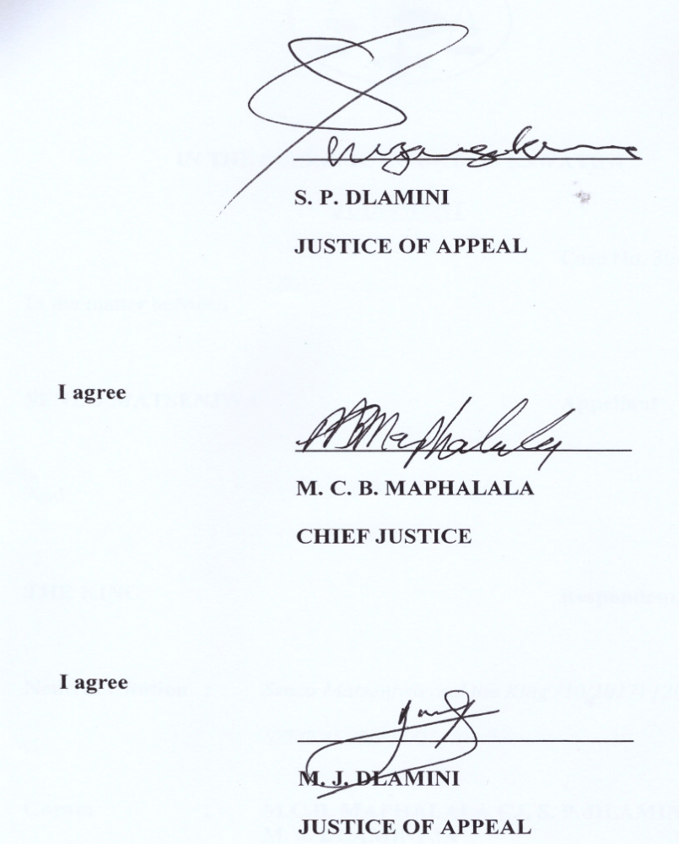
For the Appellant : Senior Crown Counsel M. Nxumalo
For the Respondent : Attorney Machawe Sithole

